UNITED STATES
SECURITIES AND EXCHANGE COMMISSION
Washington, D.C. 20549
FORM 8-K
CURRENT REPORT
PURSUANT TO SECTION 13 OR 15(d) OF THE SECURITIES EXCHANGE ACT OF 1934
Date of Report (Date of earliest event reported): May 7, 2026
KINGSTONE COMPANIES, INC.
(Exact name of registrant as specified in its charter)
Delaware |  |  |  |  |  | 000-01665 |  |  |  |  |  | 36-2476480
(State or other jurisdiction  of incorporation) |  |  |  |  |  | (Commission  File Number) |  |  |  |  |  | (IRS Employer  Identification No.)
120 Wood Road  Kingston, New York |  |  |  |  |  | 12401
(Address of principal executive offices) |  |  |  |  |  | (Zip code)
Registrant's telephone number, including area code (845) 802-7900
Securities registered pursuant to Section 12(b) of the Securities Exchange Act of 1934:
Title of each class |  |  | Trading Symbol(s) |  |  | Name of each exchange on which registered
Common Stock, $0.01 par value per share |  |  | KINS |  |  | NASDAQ
Check the appropriate box below if the Form 8-K filing is intended to simultaneously satisfy the filing obligation of the registrant under any of the following provisions (see General Instruction A.2. below):
☐ Written communications pursuant to Rule 425 under the Securities Act (17 CFR 230.425)
☐ Soliciting material pursuant to Rule 14a-12 under the Exchange Act (17 CFR 240.14a-12)
☐ Pre-commencement communications pursuant to Rule 14d-2(b) under the Exchange Act (17 CFR 240.14d-2(b))
☐ Pre-commencement communications pursuant to Rule 13e-4(c) under the Exchange Act (17 CFR 240.13e-4(c))
Indicate by check mark whether the registrant is an emerging growth company as defined in Rule 405 of the Securities Act of 1933 (§230.405 of this chapter) or Rule 12b-2 of the Securities Exchange Act of 1934 (§240.12b-2 of this chapter):
Emerging growth company ☐
If an emerging growth company, indicate by check mark if the registrant has elected not to use the extended transition period for complying with any new or revised financial accounting standards provided pursuant to Section 13(a) of the Exchange Act. o

Item 2.02 Results of Operations and Financial Condition.
On May 7, 2026, Kingstone Companies, Inc. (the “Company”) issued a press release announcing its financial results for the quarter ended March 31, 2026 (the “Press Release”). The Press Release also announced that the Company will hold a conference call for analysts and investors on May 8, 2026 at 8:30 A.M. ET. (the “Conference Call”), as previously announced on April 16, 2026, and that the Company has prepared an investor presentation (the “Presentation Materials”) that can be accessed through the Investor Relations/Events & Presentations section of the Company website (www.kingstonecompanies.com). Copies of the Press Release and the Presentation Materials are furnished as Exhibits 99.1 and 99.2, respectively, hereto.

The Company intends to use the Presentation Materials in connection with the Conference Call and may use the Presentation Materials from time to time, possibly with modification, in other presentations to current and potential investors, lenders, creditors, insurers, vendors, customers, employees and others with an interest in the Company and its business.

The information contained in the Press Release and the Presentation Materials is summary information that should be considered in the context of the Company’s filings with the Securities and Exchange Commission and other public announcements that the Company may make by press release or otherwise from time to time. The Presentation Materials speak as of the date of this Current Report on Form 8-K. While the Company may elect to update the Presentation Materials in the future or reflect events and circumstances occurring or existing after the date of this Current Report on Form 8-K, the Company specifically disclaims any obligation to do so.

The information furnished with this Item 2.02, including Exhibits 99.1 and 99.2, shall not be deemed “filed” for purposes of Section 18 of the Securities Exchange Act of 1934, as amended (the “Exchange Act”), or otherwise subject to the liabilities of that section, nor shall it be deemed incorporated by reference into any other filing under the Securities Act of 1933, as amended (the “Securities Act”), or the Exchange Act, except as expressly set forth by specific reference in such a filing

Item 7.01 Regulation FD Disclosure.
See Item 2.02 above.
The information in the Press Release and the Presentation Materials is being furnished, not filed, pursuant to this Item 7.01. Accordingly, the information in the Press Release and the Presentation Materials will not be incorporated by reference into any registration statement filed by the Company under the Securities Act unless specifically identified therein as being incorporated therein by reference. The furnishing of the information in this Current Report on Form 8-K with respect to the Press Release and the Presentation Materials is not intended to, and does not, constitute a determination or admission by the Company that the information in this Report with respect to the Press Release and the Presentation Materials is material or complete, or that investors should consider this information before making an investment decision with respect to any security of the Company.

Item 9.01 Financial Statements and Exhibits.
(d) |  |  | Exhibits:
 |  |  | 99.1 |  |  | Press release, dated May 7, 2026, issued by Kingstone Companies, Inc.
 |  |  | 99.2 |  |  | Presentation Materials
 |  |  | 104 |  |  | Cover Page Interactive Data File (embedded within the inline XBRL document).

SIGNATURES
Pursuant to the requirements of the Securities Exchange Act of 1934, the registrant has duly caused this report to be signed on its behalf by the undersigned hereunto duly authorized.
 |  |  | KINGSTONE COMPANIES, INC.
Dated: May 7, 2026 |  |  | By: |  |  | /s/ Randy Patten
 |  |  |  |  |  | Randy Patten
 |  |  |  |  |  | CFO



Kingstone Reports First Quarter 2026 Results

Net Premiums Earned Growth of 28% for Q1 2026 | Direct Premiums Written Growth1 of 20% for Q1 2026
Q1 GAAP Net Combined Ratio of 112.0% Driven by Eleven Winter Catastrophe Events in the Northeast U.S.
Q1 Underlying Combined Ratio1 Improved 5.1 Points to 88.3%
Q1 Diluted Net Loss Per Share of $0.40 | Q1 Diluted Operating Net Loss Per Share1 of $0.35
Company Reaffirms 2026 Full Year Guidance

Management to Host Conference Call Tomorrow at 8:30 a.m. Eastern Time

Kingston, NY — May 7, 2026 – Kingstone Companies, Inc. (Nasdaq: KINS) (“Kingstone” or the “Company”), a regional property and casualty insurance holding company, today announced its financial results for the first quarter ended March 31, 2026. The Company has also provided an investor presentation that can be accessed through the News & Events/Presentations section of the Company website at www.kingstonecompanies.com.

Key Financial and Operational Highlights
 |  |  |  | Three Months Ended
 |  |  |  | March 31,
($ in thousands, except per share data) |  |  |  |  |  | 2026 |  |  | 2025 |  |  | Change
Net premiums earned |  |  |  |  |  | $ | 55,869 |  | $ | 43,523 |  | 28.4%
Direct premiums written1 |  |  |  |  |  | $ | 69,603 |  | $ | 58,175 |  | 19.6%
Net combined ratio |  |  |  |  |  | 112.0% |  |  | 93.7% |  |  | 18.3pts
Catastrophe loss ratio1 |  |  |  |  |  | 26.0% |  |  | 1.7% |  |  | 24.3pts
Underlying combined ratio1 |  |  |  |  |  | 88.3% |  |  | 93.4% |  |  | (5.1)pts
Net (loss) income |  |  |  |  |  | $ | (5,808) |  | $ | 3,883 |  | (249.6)%
Net (loss) income per share - diluted |  |  |  |  |  | $ | (0.40) |  | $ | 0.27 |  | (248.1)%
Operating net (loss) income per share - diluted1 |  |  |  |  |  | $ | (0.35) |  | $ | 0.17 |  | (305.9)%
Return on equity - annualized |  |  |  |  |  | (19.6)% |  |  | 20.8% |  |  | (40.4)pts
1 Refer to section entitled "Definitions and Non-GAAP Measures" included in this press release.

Management Commentary
Meryl Golden, President and Chief Executive Officer of Kingstone, stated, “First quarter results reflected elevated winter catastrophe activity across the Northeast, resulting in a GAAP combined ratio of 112.0%. The winter storm season in Q1 was exceptionally severe for downstate New York and ranked as the coldest and snowiest in 11 years. Importantly, this level of catastrophe activity was in-line with our guidance and does not detract from the underlying strength of our business.

Excluding catastrophes, our performance underscores the earnings power of the platform we have built. Our underlying combined ratio1 improved 5.1 points year-over-year to 88.3%, supported by low non-catastrophe loss frequency, higher average premium, and continued discipline in underwriting and expense management. These results reinforce the structural profitability improvements we have made over the past several years.

Growth remained strong in the quarter with direct premiums written1 increasing 20%, driven by continued momentum in our New York homeowners business, higher average premiums, and solid retention. While policy volume was more moderate in January and February, likely due to the bad weather, March represented one of our strongest months of new business volume, reflecting sustained demand and the competitiveness of our product offering.

1
Our operating model continues to differentiate Kingstone. The increasing mix of our Select product is driving improved risk selection and loss performance, while our scalable platform enables us to grow efficiently. At the same time, our conservative reinsurance ensures that catastrophe events are an earnings event, not a capital event, allowing us to maintain financial flexibility even in periods of increased severe weather.

Looking ahead, we remain confident in our trajectory and our full year 2026 guidance. Our underlying performance trends, combined with continued rate adequacy and disciplined growth, position us well to deliver strong profitability. We are also advancing our strategic initiatives, including our planned entry into California in the second quarter and the recent launch of Kingstone America Insurance Company, which will support our expansion into new markets on an admitted and non-admitted basis, starting with Connecticut in the third quarter. We will continue to execute with discipline, manage catastrophe exposure prudently, and invest in scalable growth opportunities to deliver long-term value to our shareholders.”

Fiscal Year 2026 Outlook
(see “Disclaimer and Forward-Looking Statements” below)

The Company is reiterating its growth and profitability outlook for fiscal year 2026, which was originally issued on March 5, 2026. The guidance below reflects management’s current expectations based on information available as of May 7, 2026 and is subject to the risks and uncertainties described in “Disclaimer and Forward-Looking Statements” below.

Guidance Metrics |  |  | 2026 Estimate
Direct premiums written1,4 growth |  |  | 16% to 20%
Net combined ratio |  |  | 81% to 86%
Underlying combined ratio1,2 (excluding catastrophe losses and prior-year reserve development) |  |  | 74% to 76%
Prior-year reserve development |  |  | —%
Catastrophe loss ratio3 |  |  | 7% to 10%
Net income per share – diluted |  |  | $2.20 to $2.90
Return on equity |  |  | 24% to 30%
¹Refer to “Definitions and Non-GAAP Measures” for definitions and first quarter 2026 reconciliations.
²The Underlying Combined Ratio is a non-GAAP measure. It is computed as the sum of the underlying loss ratio (which is a non-GAAP measure) and the net underwriting expense ratio. The underlying loss ratio excludes catastrophe losses and prior-year reserve development from the GAAP net loss ratio. The most directly comparable GAAP measure is the net combined ratio. Refer to the section entitled “Definitions and Non-GAAP Measures” included in this press release for definitions and reconciliations of non-GAAP financial measures. A reconciliation of the 2026 estimate of Underlying Combined Ratio to the GAAP net combined ratio is not provided because the Company is unable to predict catastrophe losses and prior-year reserve development with reasonable certainty without unreasonable efforts. These items could materially impact the GAAP measure.
³ The catastrophe loss ratio estimate for 2026 of 7% to 10% is at or above the Company’s six-year historical average of 7.1% (2019–2024) and gives effect to the elevated winter storm activity experienced in first quarter of 2026. Catastrophe losses are reported net of reinsurance recoveries and include loss adjustment expenses. The Company defines catastrophe events consistent with PCS industry designations.
4Guidance for the most comparable GAAP measure, net premiums earned, is not provided because net premiums earned is an output of multiple variables including direct written premium growth, quota share cession rates, and premium earning patterns, several of which are not within the Company’s direct control; therefore the Company is unable to predict such variables with reasonable certainty without unreasonable efforts.

Key Modeling Assumptions
The following reflects certain key modeling assumptions with respect to the full year 2026 guidance:

Assumption |  |  | 2026E
Assumed effective tax rate |  |  | 21%
Weighted average diluted shares outstanding |  |  | 14.8 million

2
Consolidated Financial Results

Consolidated Financial Results |  |  |  |  | Three Months Ended
($ in thousands, except policy and per share data) |  |  |  |  | March 31,
 |  |  |  |  |  |  |  | 2026 |  |  | 2025 |  |  | Change
Net premiums earned |  |  |  |  |  |  |  | $ | 55,869 |  | $ | 43,523 |  | 28.4%
Direct premiums written1 |  |  |  |  |  |  |  | $ | 69,603 |  | $ | 58,175 |  | 19.6%
Policies in force, at the end of the period |  |  |  |  |  |  |  | 82,406 |  |  | 76,905 |  |  | 7.2%
Net investment income |  |  |  |  |  |  |  | $ | 3,338 |  | $ | 2,049 |  | 62.9%
Net losses on investments |  |  |  |  |  |  |  | $ | (1,015) |  | $ | (138) |  | NM
Gain on sale of real estate |  |  |  |  |  |  |  | $ | — |  | $ | 1,966 |  | NM
Net loss ratio |  |  |  |  |  |  |  | 81.6% |  |  | 62.4% |  |  | 19.2pts
Net underwriting expense ratio |  |  |  |  |  |  |  | 30.4% |  |  | 31.3% |  |  | (0.9)pts
Net combined ratio |  |  |  |  |  |  |  | 112.0% |  |  | 93.7% |  |  | 18.3pts
Net loss ratio |  |  |  |  |  |  |  | 81.6% |  |  | 62.4% |  |  | 19.2pts
Catastrophe loss ratio1 |  |  |  |  |  |  |  | 26.0% |  |  | 1.7% |  |  | 24.3pts
Net loss ratio excluding the effect of catastrophes1 |  |  |  |  |  |  |  | 55.6% |  |  | 60.7% |  |  | (5.1)pts
Effect of prior-year favorable reserve development |  |  |  |  |  |  |  | (2.3)% |  |  | (1.4)% |  |  | (0.9)pts
Underlying loss ratio1 |  |  |  |  |  |  |  | 57.9% |  |  | 62.1% |  |  | (4.2)pts
Net (loss) income |  |  |  |  |  |  |  | $ | (5,808) |  | $ | 3,883 |  | (249.6)%
Net (loss) income per share - basic |  |  |  |  |  |  |  | $ | (0.40) |  | $ | 0.29 |  | (237.9)%
Net (loss) income per share - diluted |  |  |  |  |  |  |  | $ | (0.40) |  | $ | 0.27 |  | (248.1)%
Return on equity - annualized |  |  |  |  |  |  |  | (19.6)% |  |  | 20.8% |  |  | (40.4)pts
Adjusted EBITDA1 |  |  |  |  |  |  |  | $ | (4,947) |  | $ | 4,256 |  | (216.2)%
Other comprehensive (loss) income, net of tax |  |  |  |  |  |  |  | $ | (2,055) |  | $ | 2,223 |  | (192.4)%
Operating net (loss) income1 |  |  |  |  |  |  |  | $ | (5,006) |  | $ | 2,439 |  | (305.2)%
Operating net (loss) income per share - basic1 |  |  |  |  |  |  |  | $ | (0.35) |  | $ | 0.18 |  | (294.4)%
Operating net (loss) income per share - diluted1 |  |  |  |  |  |  |  | $ | (0.35) |  | $ | 0.17 |  | (305.9)%
Operating return on equity1 |  |  |  |  |  |  |  | (4.2)% |  |  | 3.3% |  |  | (7.5)pts
Operating return on equity1 - annualized |  |  |  |  |  |  |  | (16.9)% |  |  | 13.1% |  |  | (30.0)pts
Book value per share, at the end of the period - diluted |  |  | $ | 7.70 | $ | 5.57 | 38.2%
Book value per share, at the end of the period - diluted excluding AOCI |  |  | $ | 8.25 | $ | 6.24 | 32.2%
NM = Not Meaningful
1Refer to section entitled "Definitions and Non-GAAP Measures" included in this press release.

3
Conference Call Details
Friday, May 8, 2026, at 8:30 a.m. Eastern Time

To participate please dial:

U.S. toll free 1-877-407-2991
International 1-201-389-0925

Participants are asked to dial-in approximately 10 minutes before the conference call is scheduled to begin. The conference call will also be available via live webcast on the Company’s website under the News & Events/Presentations section at www.kingstonecompanies.com. A replay will be available for 30 days.

About Kingstone Companies, Inc.
Kingstone is a regional property and casualty insurance holding company whose principal operating subsidiary is Kingstone Insurance Company ("KICO"). KICO is a New York domiciled carrier writing business through retail and wholesale agents and brokers. Kingstone delivers tailored homeowners insurance solutions through its sophisticated product suite, Select, supported by a scalable and efficient operating platform that enables the Company to pursue significant market opportunities and strategic expansion. KICO was the 11th largest writer of homeowners insurance in New York in 2025 and is also licensed in New Jersey, Rhode Island, Massachusetts, Connecticut, Pennsylvania, New Hampshire, and Maine.

Investor Relations Contact:
Elevate IR
KINS@elevate-ir.com
720-330-2829

4
Disclaimer and Forward-Looking Statements
The guidance provided above is based on information available as of May 7, 2026 and management's review of the anticipated financial results for 2026. Such guidance remains subject to change based on management's ongoing review of the Company's 2026 results and is a forward-looking statement (see below). Kingstone assumes no obligation to update this guidance. The actual results may be materially different and are affected by the risk factors and uncertainties identified in this press release and in Kingstone's annual and quarterly filings with the Securities and Exchange Commission.

This press release may contain “forward-looking statements” within the meaning of the Private Securities Litigation Reform Act of 1995. All statements, other than statements of historical facts, may be forward-looking statements. These statements are based on management’s current expectations and are subject to uncertainty and changes in circumstances. These statements involve risks and uncertainties that could cause actual results to differ materially from those included in forward-looking statements due to a variety of factors. For more details on factors that could affect expectations, see Part I, Item 1A of our Annual Report on Form 10-K for the year ended December 31, 2025.

The risks and uncertainties include, without limitation, the following:

•the risk of significant losses from catastrophes and severe weather events;
•risks related to the lack of a financial strength rating from A.M. Best;
•risks related to limitations on the ability of our insurance subsidiary to pay dividends to us;
•adverse capital, credit and financial market conditions;
•risks related to volatility in net investment income;
•the unavailability of reinsurance at current levels and prices;
•the exposure to greater net insurance losses in the event of reduced reliance on reinsurance;
•the credit risk of our reinsurers;
•the inability to maintain the requisite amount of risk-based capital needed to grow our business;
•the effects of climate change on the frequency or severity of weather events and wildfires;
•risks related to the limited market area of our business;
•risks related to a concentration of business in a limited number of producers;
•legislative and regulatory changes, including changes in insurance laws and regulations and their application by our regulators;
•the effects of competition in our market areas;
•our reliance on certain key personnel;
•risks related to security breaches or other attacks involving our computer systems or those of our vendors;
•our reliance on information technology and information systems; and
•the uncertainty relating to our geographic diversification strategy in entering the California market and other markets.

Kingstone undertakes no obligation to publicly update or revise any forward-looking statements, whether as a result of new information, future events or otherwise, except as required by law.

5
Definitions and Non-GAAP Measures

Direct premiums written is a non-GAAP measure, which represent the total premiums charged on policies issued by the Company during the respective fiscal period.

Net premiums written is a non-GAAP measure, which are direct premiums written less premiums ceded to reinsurers. Net premiums earned, the GAAP measure most comparable to direct premiums written and net premiums written, are net premiums written that are pro-rata earned during the fiscal period presented. All of the Company’s policies are written for a twelve-month period. Management uses direct premiums written and net premiums written, along with other measures, to gauge the Company’s performance and evaluate results. Direct premiums written and net premiums written are provided as supplemental information, not as a substitute for net premiums earned, and do not reflect the Company’s net premiums earned.

Adjusted EBITDA is a non-GAAP measure, which is net income (loss) exclusive of interest expense, income tax expense (benefit), depreciation and amortization, loss on extinguishment of debt, net gains (losses) on investments, gain on sale of real estate, and stock-based compensation. Net income (loss) is the GAAP measure most closely comparable to adjusted EBITDA.

Management uses adjusted EBITDA along with other measures to gauge the Company’s performance and evaluate results, which can be skewed when including interest expense, income tax expense (benefit), depreciation and amortization, loss on extinguishment of debt, net gains (losses) on investments, gain on sale of real estate, and stock-based compensation, and may vary significantly between periods. Adjusted EBITDA is provided as supplemental information, not as a substitute for net income and does not reflect the Company’s overall profitability.

Operating net income (loss) and basic operating net income (loss) per share is a non-GAAP measure, which is net income (loss) and basic income (loss) per share exclusive of net gains (losses) on investments and gain on sale of real estate, net of tax. Net income (loss) and basic net income (loss) per share are the GAAP measures most closely comparable to operating net income (loss) and basic operating net income (loss) per share.

Management uses operating net income (loss) and basic operating net income (loss) per share along with other measures to gauge the Company’s performance and evaluate results, which can be skewed when including net gains (losses) on investments and gain on sale of real estate and may vary significantly between periods. Operating net income (loss) and basic operating net income (loss) per share are provided as supplemental information, not as a substitute for net income (loss) and basic net income (loss) per share and do not reflect the Company’s overall profitability.

Operating net income (loss) and diluted operating net income (loss) per share is a non-GAAP measure, which is net income (loss) and diluted income (loss) per share exclusive of net gains (losses) on investments and gain on sale of real estate, net of tax. Net income (loss) and diluted net income (loss) per share are the GAAP measures most closely comparable to operating net income (loss) and diluted operating net income (loss) per share.

Management uses operating net income (loss) and diluted operating net income (loss) per share along with other measures to gauge the Company’s performance and evaluate results, which can be skewed when including net gains (losses) on investments and gain on sale of real estate and may vary significantly between periods. Operating net income (loss) and diluted operating net income (loss) per share are provided as supplemental information, not as a substitute for net income (loss) and diluted net income (loss) per share, and do not reflect the Company’s overall profitability.

Operating return on equity is a non-GAAP measure, which is operating income (loss) divided by average equity. Return on equity is the GAAP measure most closely comparable to operating return on equity.

Management uses operating return on equity, along with other measures, to gauge the Company’s performance and evaluate results, which can be skewed when including net gains (losses) on investments and gain on sale of real estate, which may vary significantly between periods. Operating return on equity is provided as supplemental information, is not a substitute for return on equity and does not reflect the Company’s overall return on average common equity.

Underlying loss ratio is a non-GAAP ratio, which is computed as the GAAP net loss ratio excluding the effect of prior year loss reserve development and catastrophe losses.

Management believes that this ratio is useful to investors, and it is used by management to reveal the trends in the Company’s business that may be obscured by prior year loss reserve development and catastrophe losses. Catastrophe losses cause the Company’s loss ratios to vary significantly between periods as a result of their incidence of occurrence and magnitude and can have a significant impact on the net loss ratio. Management believes that this measure is useful for investors to evaluate this component separately when reviewing the Company’s underwriting performance. The most directly comparable GAAP measure is the net loss ratio. The underlying loss ratio should not be considered a substitute for the net loss ratio and does not reflect the Company’s net loss ratio.

Net loss ratio excluding the effect of catastrophes is a non-GAAP ratio, which is computed as the difference between GAAP net loss ratio and the effect of catastrophes on the net loss ratio.

6
Management believes that this ratio is useful to investors, and it is used by management to reveal the trends in the Company’s business that may be obscured by catastrophe losses. Catastrophe losses cause the Company’s net loss ratios to vary significantly between periods as a result of their incidence of occurrence and magnitude and can have a significant impact on the net loss ratio. Management believes that this measure is useful for investors to evaluate this component separately when reviewing the Company’s underwriting performance. The most directly comparable GAAP measure is the net loss ratio. The net loss ratio excluding the effect of catastrophes should not be considered a substitute for the net loss ratio and does not reflect the Company’s net loss ratio.

Underlying combined ratio is a non-GAAP measure, which is computed as the sum of the underlying loss ratio and the net underwriting expense ratio.

Management believes that this ratio is useful to investors, and it is used by management to reveal the trends in the Company’s business that may be obscured by prior year loss reserve development and catastrophe losses. Catastrophe losses cause the Company’s loss ratios to vary significantly between periods as a result of their incidence of occurrence and magnitude and can have a significant impact on the net combined ratio. Management believes that this measure is useful for investors to evaluate this component separately when reviewing the Company’s underwriting performance. The most directly comparable GAAP measure is the net combined ratio. The underlying combined ratio should not be considered a substitute for the net combined ratio and does not reflect the Company’s net combined ratio.

7
The table below reconciles net premiums earned to direct premiums written for the periods presented:

 |  |  |  |  | For the Three Months Ended
 |  |  |  |  | March 31,
 |  |  |  |  |  |  |  |  |  |  |  |  |  |  |  |  |  |  | %
(000’s except percentages) |  |  |  |  |  |  |  |  | 2026 |  |  |  | 2025 |  |  |  |  |  | Change
Direct Premiums Written Reconciliation:
GAAP net premiums earned |  |  |  |  |  |  |  |  |  | $ | 55,869 |  |  |  |  | $ | 43,523 |  |  |  |  | 28.4 |  |  | %
Change in unearned premiums |  |  |  |  |  |  |  |  |  | 21,724 |  |  |  |  |  | 17,486 |  |  |  |  |  | 24.2
Net premiums written |  |  |  |  |  |  |  |  |  | 77,593 |  |  |  |  |  | 61,009 |  |  |  |  |  | 27.2
Ceded written premiums |  |  |  |  |  |  |  |  |  | 7,990 |  |  |  |  |  | 2,834 |  |  |  |  |  | 181.9
Direct premiums written |  |  |  |  |  |  |  |  |  | $ | 69,603 |  |  |  |  | $ | 58,175 |  |  |  |  | 19.6 |  |  | %
(Components may not sum due to rounding)

The following table reconciles net (loss) income to adjusted EBITDA for the periods indicated:

 |  |  |  |  | For the Three Months Ended
 |  |  |  |  | March 31,
 |  |  |  |  |  |  |  |  |  |  |  |  |  |  |  |  |  |  | %
(000’s except percentages) |  |  |  |  |  |  |  |  | 2026 |  |  |  | 2025 |  |  |  |  |  | Change
Adjusted EBITDA Reconciliation:
Net (loss) income |  |  |  |  |  |  |  |  |  | $ | (5,808) |  |  |  |  | $ | 3,883 |  |  |  |  | (249.6) |  |  | %
Interest expense |  |  |  |  |  |  |  |  |  | 70 |  |  |  |  |  | 227 |  |  |  |  |  | (69.2)
Income tax (benefit) expense |  |  |  |  |  |  |  |  |  | (1,593) |  |  |  |  |  | 836 |  |  |  |  |  | (290.6)
Depreciation and amortization |  |  |  |  |  |  |  |  |  | 716 |  |  |  |  |  | 624 |  |  |  |  |  | 14.7
EBITDA |  |  |  |  |  |  |  |  |  | (6,616) |  |  |  |  |  | 5,570 |  |  |  |  |  | (218.8)
Loss on extinguishment of debt |  |  |  |  |  |  |  |  |  | — |  |  |  |  |  | 175 |  |  |  |  |  | (100.0)
Net loss on investments |  |  |  |  |  |  |  |  |  | 1,015 |  |  |  |  |  | 138 |  |  |  |  |  | NM
Gain on sale of real estate |  |  |  |  |  |  |  |  |  | — |  |  |  |  |  | (1,966) |  |  |  |  |  | NM
Stock-based compensation |  |  |  |  |  |  |  |  |  | 654 |  |  |  |  |  | 339 |  |  |  |  |  | 92.9
Adjusted EBITDA |  |  |  |  |  |  |  |  |  | $ | (4,947) |  |  |  |  | $ | 4,256 |  |  |  |  | (216.2) |  |  | %
NM = Not Meaningful
(Components may not sum due to rounding)

8
The following table reconciles net (loss) income to operating net (loss) income and basic net (loss) income per share to basic operating net (loss) income per share for the periods indicated:

 |  |  |  |  | For the Three Months Ended
 |  |  |  |  |  |  | March 31, 2026 |  |  |  | March 31, 2025
(000’s except per common share and outstanding share amounts) |  |  |  |  |  |  |  |  |  |  | Amount |  |  |  |  |  | Basic loss per common share |  |  |  |  |  | Amount |  |  |  |  |  | Basic income per common share
Net (loss) income |  |  |  |  |  |  |  |  |  |  | $ | (5,808) |  |  |  |  | $ | (0.40) |  |  |  |  | $ | 3,883 |  |  |  |  | $ | 0.29
Net loss on investments |  |  |  |  |  |  |  |  |  |  | 1,015 |  |  |  |  |  |  |  |  |  |  |  | 138
Gain on sale of real estate |  |  |  |  |  |  |  |  |  |  | — |  |  |  |  |  |  |  |  |  |  |  | (1,966)
Net loss on investments and (gain) on sale of real estate |  |  |  |  |  |  |  |  |  |  | 1,015 |  |  |  |  |  |  |  |  |  |  |  | (1,828)
Less tax expense (benefit) on net loss (gain) |  |  |  |  |  |  |  |  |  |  | 213 |  |  |  |  |  |  |  |  |  |  |  | (384)
Net loss on investments and (gain) on sale of real estate, net of taxes |  |  |  |  |  |  |  |  |  |  | 802 |  |  |  |  |  | $ | 0.05 |  |  |  |  | (1,444) |  |  |  |  |  | $ | (0.11)
Operating net (loss) income |  |  |  |  |  |  |  |  |  |  | $ | (5,006) |  |  |  |  | $ | (0.35) |  |  |  |  | $ | 2,439 |  |  |  |  | $ | 0.18
Weighted average basic shares outstanding |  |  |  |  |  |  |  |  |  |  | 14,453,747 |  |  |  |  |  |  |  |  |  |  |  | 13,472,404
(Components may not sum due to rounding)

9
The following table reconciles net (loss) income to operating net (loss) income and diluted net (loss) income per share to diluted operating net (loss) income per share for the periods indicated:

 |  |  |  |  | For the Three Months Ended
 |  |  |  |  |  |  | March 31, 2026 |  |  |  | March 31, 2025
(000’s except per common share and outstanding share amounts) |  |  |  |  |  |  |  |  |  |  | Amount |  |  |  |  |  | Diluted loss per common share |  |  |  |  |  | Amount |  |  |  |  |  | Diluted income per common share
Net (loss) income |  |  |  |  |  |  |  |  |  |  | $ | (5,808) |  |  |  |  | $ | (0.40) |  |  |  |  | $ | 3,883 |  |  |  |  | $ | 0.27
Net loss on investments |  |  |  |  |  |  |  |  |  |  | 1,015 |  |  |  |  |  |  |  |  |  |  |  | 138
Gain on sale of real estate |  |  |  |  |  |  |  |  |  |  | — |  |  |  |  |  |  |  |  |  |  |  | (1,966)
Net loss on investments and (gain) on sale of real estate |  |  |  |  |  |  |  |  |  |  | 1,015 |  |  |  |  |  |  |  |  |  |  |  | (1,828)
Less tax expense (benefit) on net loss (gain) |  |  |  |  |  |  |  |  |  |  | 213 |  |  |  |  |  |  |  |  |  |  |  | (384)
Net loss on investments and (gain) on sale of real estate, net of taxes |  |  |  |  |  |  |  |  |  |  | 802 |  |  |  |  |  | $ | 0.05 |  |  |  |  | (1,444) |  |  |  |  |  | $ | (0.10)
Operating net (loss) income |  |  |  |  |  |  |  |  |  |  | $ | (5,006) |  |  |  |  | $ | (0.35) |  |  |  |  | $ | 2,439 |  |  |  |  | $ | 0.17
Weighted average diluted shares outstanding |  |  |  |  |  |  |  |  |  |  | 14,453,747 |  |  |  |  |  |  |  |  |  |  |  | 14,272,502
(Components may not sum due to rounding)

10
The following table reconciles net (loss) income to operating net (loss) income and return on equity to operating return on equity for the periods indicated:

 |  |  |  |  | For the Three Months Ended
 |  |  |  |  | March 31,
(000’s except percentages) |  |  |  |  |  |  |  |  | 2026 |  |  |  |  |  | 2025 |  |  |  |  |  | Change
Operating Net Income Reconciliation:
Net (loss) income |  |  |  |  |  |  |  |  | $ | (5,808) |  |  |  |  | $ | 3,883 |  |  |  |  | (249.6)%
Net loss on investments |  |  |  |  |  |  |  |  | 1,015 |  |  |  |  |  | 138 |  |  |  |  |  | NM
Gain on sale of real estate |  |  |  |  |  |  |  |  | — |  |  |  |  |  | (1,966) |  |  |  |  |  | (100.0)%
Net loss on investments and (gain) on sale of real estate |  |  |  |  |  |  |  |  | 1,015 |  |  |  |  |  | (1,828) |  |  |  |  |  | (155.5)%
Less tax expense (benefit) on net loss (gain) |  |  |  |  |  |  |  |  | 213 |  |  |  |  |  | (384) |  |  |  |  |  | (155.5)%
Net loss on investments and (gain) on sale of real estate, net of taxes |  |  |  |  |  |  |  |  | 802 |  |  |  |  |  | (1,444) |  |  |  |  |  | (155.5)%
Operating net (loss) income |  |  |  |  |  |  |  |  | $ | (5,006) |  |  |  |  | $ | 2,439 |  |  |  |  | (305.2)%
Operating Return on Equity Reconciliation:
Net (loss) income |  |  |  |  |  |  |  |  | $ | (5,808) |  |  |  |  | $ | 3,883 |  |  |  |  | (249.6)%
Average equity |  |  |  |  |  |  |  |  | $ | 118,618 |  |  |  |  | $ | 74,459 |  |  |  |  | 59.3%
Return on equity |  |  |  |  |  |  |  |  | (4.9)% |  |  |  |  |  | 5.2% |  |  |  |  |  | (10.1)pts
Return on equity - annualized |  |  |  |  |  |  |  |  | (19.6)% |  |  |  |  |  | 20.8% |  |  |  |  |  | (40.4)pts
Net loss on investments and (gain) on sale of real estate |  |  |  |  |  |  |  |  | $ | 802 |  |  |  |  | $ | (1,444) |  |  |  |  | (155.5)%
Average equity |  |  |  |  |  |  |  |  | $ | 118,618 |  |  |  |  | $ | 74,459 |  |  |  |  | 59.3%
Effect of net loss on investments and gain on sale of real estate, net of taxes, on return on equity |  |  |  |  |  |  |  |  | 0.7% |  |  |  |  |  | (1.9)% |  |  |  |  |  | 2.6pts
Operating net (loss) income |  |  |  |  |  |  |  |  | $ | (5,006) |  |  |  |  | $ | 2,439 |  |  |  |  | (305.2)%
Operating net (loss) income - annualized |  |  |  |  |  |  |  |  | $ | (20,024) |  |  |  |  | $ | 9,756 |  |  |  |  | (305.2)%
Average equity |  |  |  |  |  |  |  |  | $ | 118,618 |  |  |  |  | $ | 74,459 |  |  |  |  | 59.3%
Operating return on equity |  |  |  |  |  |  |  |  | (4.2)% |  |  |  |  |  | 3.3% |  |  |  |  |  | (7.5)pts
Operating return on equity - annualized |  |  |  |  |  |  |  |  | (16.9)% |  |  |  |  |  | 13.1% |  |  |  |  |  | (30.0)pts
NM = Not Meaningful
(Components may not sum due to rounding)

11
The following table reconciles the net loss ratio to the underlying loss ratio, which excludes the effect of catastrophe losses and prior-year loss reserve development for the periods presented:

 |  |  |  |  | For the Three Months Ended
 |  |  |  |  | March 31,
 |  |  |  |  |  |  |  |  | 2026 |  |  |  | 2025 |  |  |  |  |  | Percentage Point Change
Underlying Loss Ratio Reconciliation:
Net loss ratio |  |  |  |  |  |  |  |  |  | 81.6% |  |  |  |  |  | 62.4% |  |  |  |  |  | 19.2 |  |  | pts
Effect of catastrophes |  |  |  |  |  |  |  |  |  | 26.0% |  |  |  |  |  | 1.7% |  |  |  |  |  | 24.3 |  |  | pts
Net loss ratio excluding the effect of catastrophes |  |  |  |  |  |  |  |  |  | 55.6% |  |  |  |  |  | 60.7% |  |  |  |  |  | (5.1) |  |  | pts
Effect of prior-year favorable reserve development |  |  |  |  |  |  |  |  |  | (2.3)% |  |  |  |  |  | (1.4)% |  |  |  |  |  | (0.9) |  |  | pts
Underlying Loss Ratio |  |  |  |  |  |  |  |  |  | 57.9% |  |  |  |  |  | 62.1% |  |  |  |  |  | (4.2) |  |  | pts
(Components may not sum due to rounding)

The following table reconciles the net combined ratio to the underlying combined ratio, which excludes the effect of catastrophe losses and prior-year loss reserve development for the periods presented:

 |  |  |  |  | For the Three Months Ended
 |  |  |  |  | March 31,
 |  |  |  |  |  |  |  |  | 2026 |  |  |  | 2025 |  |  |  |  |  | Percentage Point Change
Underlying Combined Ratio Reconciliation:
Net combined ratio |  |  |  |  |  |  |  |  |  | 112.0% |  |  |  |  |  | 93.7% |  |  |  |  |  | 18.3 |  |  | pts
Effect of catastrophes |  |  |  |  |  |  |  |  |  | 26.0% |  |  |  |  |  | 1.7% |  |  |  |  |  | 24.3 |  |  | pts
Effect of prior-year favorable reserve development |  |  |  |  |  |  |  |  |  | (2.3)% |  |  |  |  |  | (1.4)% |  |  |  |  |  | (0.9) |  |  | pts
Underlying combined ratio |  |  |  |  |  |  |  |  |  | 88.3% |  |  |  |  |  | 93.4% |  |  |  |  |  | (5.1) |  |  | pts
(Components may not sum due to rounding)

12
KINGSTONE COMPANIES, INC. AND SUBSIDIARIES
Condensed Consolidated Balance Sheets
 |  |  | March 31,  2026 |  |  | December 31,  2025
 |  |  | (unaudited)
Assets
Fixed-maturity securities, held-to-maturity, at amortized cost (fair value of
$5,053,137 at March 31, 2026 and $5,137,267 at December 31, 2025) |  |  | $ | 6,041,016 |  | $ | 6,042,348
Fixed-maturity securities, available-for-sale, at fair value (amortized cost of
$304,102,884 at March 31, 2026 and $296,738,055 at December 31, 2025) |  |  | 293,800,426 |  |  | 289,037,190
Equity securities, at fair value (cost of $13,546,654 at March 31, 2026 and $13,546,654 at December 31, 2025) |  |  | 9,839,800 |  |  | 10,056,595
Other investments |  |  | 3,756,749 |  |  | 4,552,378
Total investments |  |  | 313,437,991 |  |  | 309,688,511
Cash and cash equivalents |  |  | 11,355,391 |  |  | 12,178,730
Premiums receivable, net of allowance for credit losses of $53,299 at March 31, 2026 and $20,831 at December 31, 2025 |  |  | 19,027,968 |  |  | 21,012,408
Reinsurance receivables, net |  |  | 57,996,924 |  |  | 58,996,945
Prepaid reinsurance |  |  | 4,934,974 |  |  | 2,142,329
Deferred policy acquisition costs |  |  | 27,799,748 |  |  | 27,867,207
Intangible assets |  |  | 500,000 |  |  | 500,000
Property and equipment, net |  |  | 8,017,975 |  |  | 7,897,675
Deferred income taxes, net |  |  | 6,318,887 |  |  | 4,179,559
Other assets |  |  | 15,949,185 |  |  | 8,961,787
Total assets |  |  | $ | 465,339,043 |  | $ | 453,425,151
Liabilities
Loss and loss adjustment expense reserves |  |  | $ | 171,748,662 |  | $ | 140,538,618
Unearned premiums |  |  | 153,642,731 |  |  | 154,028,072
Advance premiums |  |  | 5,897,368 |  |  | 4,003,453
Reinsurance balances payable |  |  | 4,775,176 |  |  | 5,232,319
Deferred ceding commission revenue |  |  | 2,818,444 |  |  | 8,362,529
Accounts payable, accrued expenses and other liabilities |  |  | 4,984,969 |  |  | 11,253,649
Income taxes payable |  |  | 2,844,212 |  |  | 2,835,135
Debt, net (current $1,315,984 and long-term $2,806,987 at March 31, 2026,
current $1,296,900 and long-term $3,143,227 at December 31, 2025) |  |  | 4,122,971 |  |  | 4,440,127
Total liabilities |  |  | 350,834,533 |  |  | 330,693,902
Commitments and Contingencies |  |  | — |  |  | —
Stockholders' Equity
Preferred stock, $.01 par value; authorized 2,500,000 shares |  |  | — |  |  | —
Common stock, $0.01 par value; authorized 20,000,000 shares; issued 16,006,728 shares at March 31, 2026 and 15,921,651 shares at December 31, 2025; outstanding 14,482,603 shares at March 31, 2026 and 14,397,526 shares at December 31, 2025 |  |  | 160,066 |  |  | 159,216
Capital in excess of par |  |  | 99,982,907 |  |  | 99,624,713
Accumulated other comprehensive loss |  |  | (8,136,787) |  |  | (6,081,530)
Retained earnings |  |  | 28,066,331 |  |  | 34,596,857
 |  |  | 120,072,517 |  |  | 128,299,256
Treasury stock, at cost, 1,524,125 shares at March 31, 2026 and December 31, 2025 |  |  | (5,568,007) |  |  | (5,568,007)
Total stockholders' equity |  |  | 114,504,510 |  |  | 122,731,249
Total liabilities and stockholders' equity |  |  | $ | 465,339,043 |  | $ | 453,425,151

13

KINGSTONE COMPANIES, INC. AND SUBSIDIARIES
Condensed Consolidated Statements of (Loss) Income and Comprehensive (Loss) Income (Unaudited)
 |  |  |  |  | For the Three Months Ended
 |  |  |  |  | March 31,
 |  |  |  |  |  |  | 2026 |  |  |  |  |  | 2025
Revenues
Net premiums earned |  |  |  |  |  |  | $ | 55,868,814 |  |  |  |  | $ | 43,523,063
Ceding commission revenue |  |  |  |  |  |  | 1,403,876 |  |  |  |  |  | 2,958,691
Net investment income |  |  |  |  |  |  | 3,337,581 |  |  |  |  |  | 2,048,596
Net losses on investments |  |  |  |  |  |  | (1,015,347) |  |  |  |  |  | (137,979)
Gain on sale of real estate |  |  |  |  |  |  | — |  |  |  |  |  | 1,965,989
Other income |  |  |  |  |  |  | 180,812 |  |  |  |  |  | 140,415
Total revenues |  |  |  |  |  |  | 59,775,736 |  |  |  |  |  | 50,498,775
Expenses
Loss and loss adjustment expenses |  |  |  |  |  |  | 45,574,384 |  |  |  |  |  | 27,175,078
Commission expense |  |  |  |  |  |  | 10,195,412 |  |  |  |  |  | 9,312,880
Other underwriting expenses |  |  |  |  |  |  | 8,361,273 |  |  |  |  |  | 7,405,422
Other operating expenses |  |  |  |  |  |  | 2,260,547 |  |  |  |  |  | 1,035,737
Depreciation and amortization |  |  |  |  |  |  | 715,507 |  |  |  |  |  | 623,863
Interest expense |  |  |  |  |  |  | 69,855 |  |  |  |  |  | 227,454
Total expenses |  |  |  |  |  |  | 67,176,978 |  |  |  |  |  | 45,780,434
(Loss) income from operations before taxes |  |  |  |  |  |  | (7,401,242) |  |  |  |  |  | 4,718,341
Income tax (benefit) expense |  |  |  |  |  |  | (1,592,992) |  |  |  |  |  | 835,681
Net (loss) income |  |  |  |  |  |  | $ | (5,808,250) |  |  |  |  | $ | 3,882,660
Other comprehensive (loss) income, net of tax
Gross (increase) decrease in net unrealized losses
on available-for-sale-securities |  |  |  |  |  |  | $ | (2,604,516) |  |  |  |  | $ | 2,812,432
Reclassification adjustment for net losses
included in net (loss) income |  |  |  |  |  |  | 2,923 |  |  |  |  |  | 1,726
Net (increase) decrease in net unrealized losses |  |  |  |  |  |  | (2,601,593) |  |  |  |  |  | 2,814,158
Income tax benefit (expense) related to items
of other comprehensive (loss) income |  |  |  |  |  |  | 546,336 |  |  |  |  |  | (590,972)
Other comprehensive (loss) income, net of tax |  |  |  |  |  |  | (2,055,257) |  |  |  |  |  | 2,223,186
Comprehensive (loss) income |  |  |  |  |  |  | $ | (7,863,507) |  |  |  |  | $ | 6,105,846
(Loss) earnings per common share:
Basic |  |  |  |  |  |  | $ | (0.40) |  |  |  |  | $ | 0.29
Diluted |  |  |  |  |  |  | $ | (0.40) |  |  |  |  | $ | 0.27
Weighted average common shares outstanding
Basic |  |  |  |  |  |  | 14,453,747 |  |  |  |  |  | 13,472,404
Diluted |  |  |  |  |  |  | 14,453,747 |  |  |  |  |  | 14,272,502
Dividends declared and paid per common share |  |  |  |  |  |  | $ | 0.05 |  |  |  |  | $ | –

14
1Q26 Earnings Presentation May 7, 2026

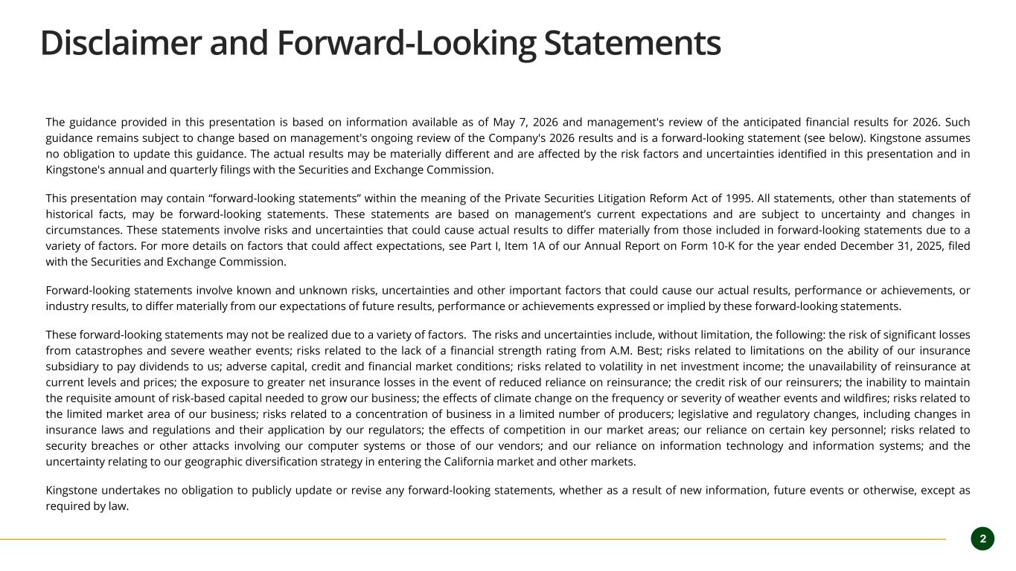
Disclaimer and Forward-Looking Statements The guidance provided in this presentation is based on information available as of May 7, 2026 and management's review of the anticipated financial results for 2026. Such guidance remains subject to change based on management's ongoing review of the Company's 2026 results and is a forward-looking statement (see below). Kingstone assumes no obligation to update this guidance. The actual results may be materially different and are affected by the risk factors and uncertainties identified in this presentation and in Kingstone's annual and quarterly filings with the Securities and Exchange Commission. This presentation may contain “forward-looking statements” within the meaning of the Private Securities Litigation Reform Act of 1995. All statements, other than statements of historical facts, may be forward-looking statements. These statements are based on management’s current expectations and are subject to uncertainty and changes in circumstances. These statements involve risks and uncertainties that could cause actual results to differ materially from those included in forward-looking statements due to a variety of factors. For more details on factors that could affect expectations, see Part I, Item 1A of our Annual Report on Form 10-K for the year ended December 31, 2025, filed with the Securities and Exchange Commission. Forward-looking statements involve known and unknown risks, uncertainties and other important factors that could cause our actual results, performance or achievements, or industry results, to differ materially from our expectations of future results, performance or achievements expressed or implied by these forward-looking statements. These forward-looking statements may not be realized due to a variety of factors. The risks and uncertainties include, without limitation, the following: the risk of significant losses from catastrophes and severe weather events; risks related to the lack of a financial strength rating from A.M. Best; risks related to limitations on the ability of our insurance subsidiary to pay dividends to us; adverse capital, credit and financial market conditions; risks related to volatility in net investment income; the unavailability of reinsurance at current levels and prices; the exposure to greater net insurance losses in the event of reduced reliance on reinsurance; the credit risk of our reinsurers; the inability to maintain the requisite amount of risk-based capital needed to grow our business; the effects of climate change on the frequency or severity of weather events and wildfires; risks related to the limited market area of our business; risks related to a concentration of business in a limited number of producers; legislative and regulatory changes, including changes in insurance laws and regulations and their application by our regulators; the effects of competition in our market areas; our reliance on certain key personnel; risks related to security breaches or other attacks involving our computer systems or those of our vendors; and our reliance on information technology and information systems; and the uncertainty relating to our geographic diversification strategy in entering the California market and other markets. Kingstone undertakes no obligation to publicly update or revise any forward-looking statements, whether as a result of new information, future events or otherwise, except as required by law. 2

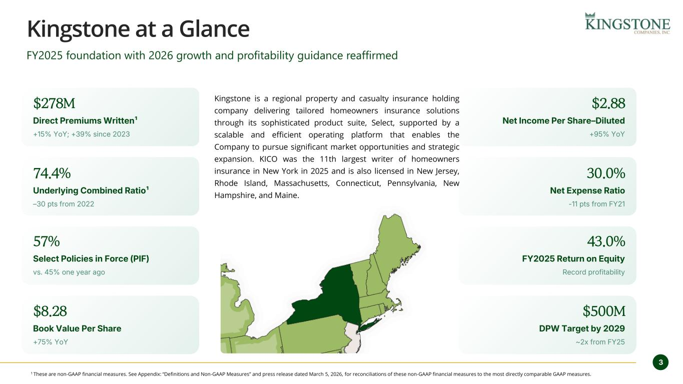
3 Kingstone at a Glance Kingstone is a regional property and casualty insurance holding company delivering tailored homeowners insurance solutions through its sophisticated product suite, Select, supported by a scalable and efficient operating platform that enables the Company to pursue significant market opportunities and strategic expansion. KICO was the 11th largest writer of homeowners insurance in New York in 2025 and is also licensed in New Jersey, Rhode Island, Massachusetts, Connecticut, Pennsylvania, New Hampshire, and Maine. $278M Direct Premiums Written¹ +15% YoY; +39% since 2023 74.4% Underlying Combined Ratio¹ –30 pts from 2022 57% Select Policies in Force (PIF) vs. 45% one year ago $8.28 Book Value Per Share +75% YoY $2.88 Net Income Per Share–Diluted +95% YoY 30.0% Net Expense Ratio -11 pts from FY21 43.0% FY2025 Return on Equity Record profitability $500M DPW Target by 2029 ~2x from FY25 FY2025 foundation with 2026 growth and profitability guidance reaffirmed 1 These are non-GAAP financial measures. See Appendix: “Definitions and Non-GAAP Measures” and press release dated March 5, 2026, for reconciliations of these non-GAAP financial measures to the most directly comparable GAAP measures.

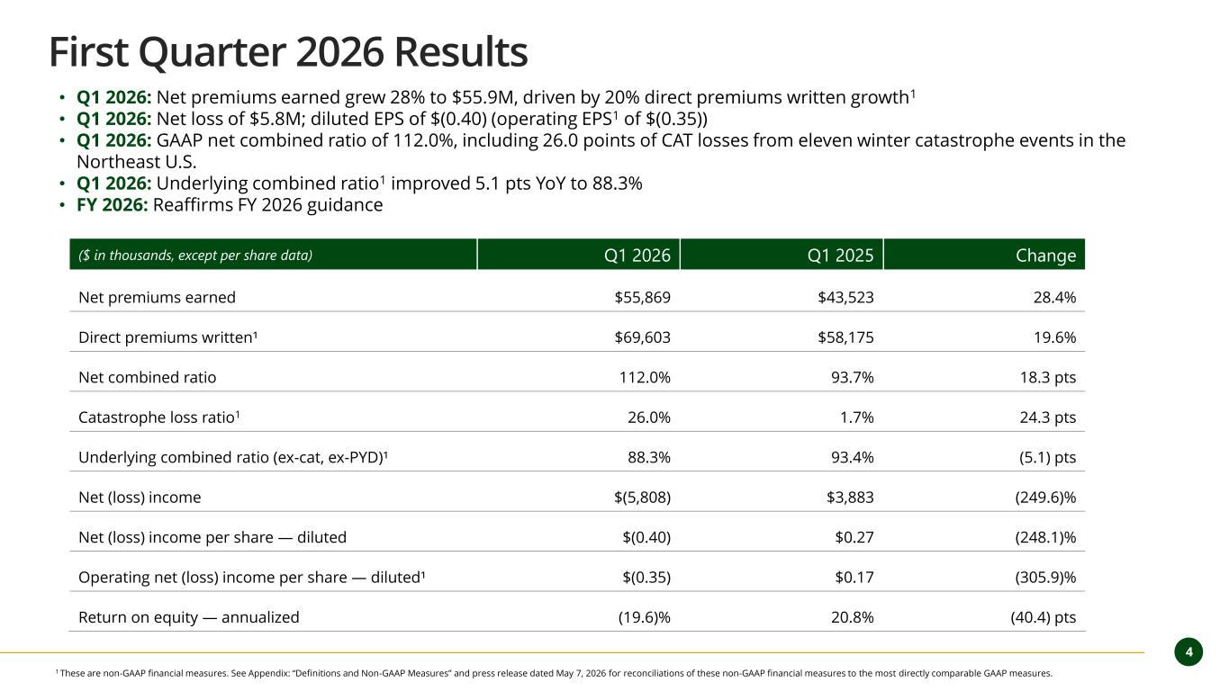
4 First Quarter 2026 Results ($ in thousands, except per share data) Q1 2026 Q1 2025 Change Net premiums earned $55,869 $43,523 28.4% Direct premiums written¹ $69,603 $58,175 19.6% Net combined ratio 112.0% 93.7% 18.3 pts Catastrophe loss ratio1 26.0% 1.7% 24.3 pts Underlying combined ratio (ex-cat, ex-PYD)¹ 88.3% 93.4% (5.1) pts Net (loss) income $(5,808) $3,883 (249.6)% Net (loss) income per share — diluted $(0.40) $0.27 (248.1)% Operating net (loss) income per share — diluted¹ $(0.35) $0.17 (305.9)% Return on equity — annualized (19.6)% 20.8% (40.4) pts • Q1 2026: Net premiums earned grew 28% to $55.9M, driven by 20% direct premiums written growth1 • Q1 2026: Net loss of $5.8M; diluted EPS of $(0.40) (operating EPS1 of $(0.35)) • Q1 2026: GAAP net combined ratio of 112.0%, including 26.0 points of CAT losses from eleven winter catastrophe events in the Northeast U.S. • Q1 2026: Underlying combined ratio1 improved 5.1 pts YoY to 88.3% • FY 2026: Reaffirms FY 2026 guidance 1 These are non-GAAP financial measures. See Appendix: “Definitions and Non-GAAP Measures” and press release dated May 7, 2026 for reconciliations of these non-GAAP financial measures to the most directly comparable GAAP measures.

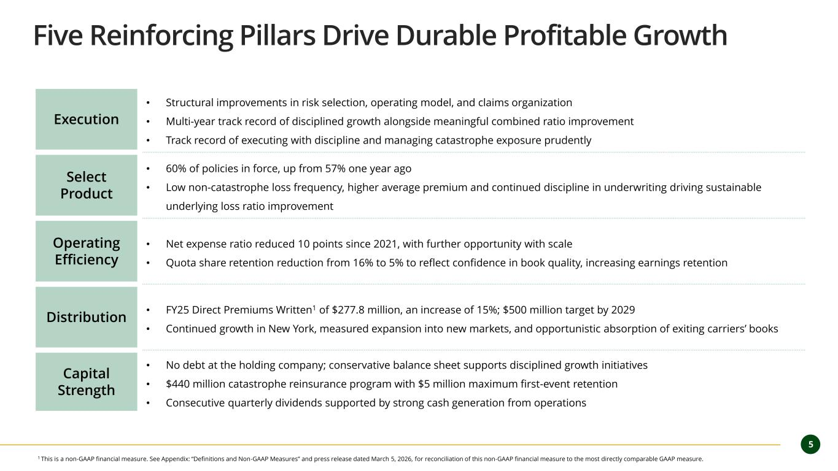
5 Five Reinforcing Pillars Drive Durable Profitable Growth Execution • Structural improvements in risk selection, operating model, and claims organization • Multi-year track record of disciplined growth alongside meaningful combined ratio improvement • Track record of executing with discipline and managing catastrophe exposure prudently Select Product • 60% of policies in force, up from 57% one year ago • Low non-catastrophe loss frequency, higher average premium and continued discipline in underwriting driving sustainable underlying loss ratio improvement Operating Efficiency • Net expense ratio reduced 10 points since 2021, with further opportunity with scale • Quota share retention reduction from 16% to 5% to reflect confidence in book quality, increasing earnings retention Distribution • FY25 Direct Premiums Written1 of $277.8 million, an increase of 15%; $500 million target by 2029 • Continued growth in New York, measured expansion into new markets, and opportunistic absorption of exiting carriers’ books Capital Strength • No debt at the holding company; conservative balance sheet supports disciplined growth initiatives • $440 million catastrophe reinsurance program with $5 million maximum first-event retention • Consecutive quarterly dividends supported by strong cash generation from operations 1 This is a non-GAAP financial measure. See Appendix: “Definitions and Non-GAAP Measures” and press release dated March 5, 2026, for reconciliation of this non-GAAP financial measure to the most directly comparable GAAP measure.

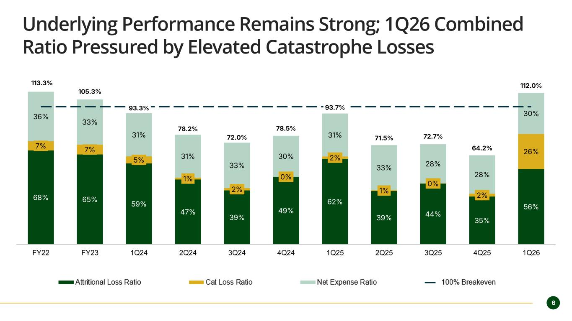
6 Underlying Performance Remains Strong; 1Q26 Combined Ratio Pressured by Elevated Catastrophe Losses 68% 65% 59% 47% 39% 49% 62% 39% 44% 35% 56% 7% 7% 5% 1% 2% 0% 2% 1% 0% 2% 26% 36% 33% 31% 31% 33% 30% 31% 33% 28% 28% 30% 113.3% 105.3% 93.3% 78.2% 72.0% 78.5% 93.7% 71.5% 72.7% 64.2% 112.0% FY22 FY23 1Q24 2Q24 3Q24 4Q24 1Q25 2Q25 3Q25 4Q25 1Q26 Attritional Loss Ratio Cat Loss Ratio Expense Ratio 100% Breakeven

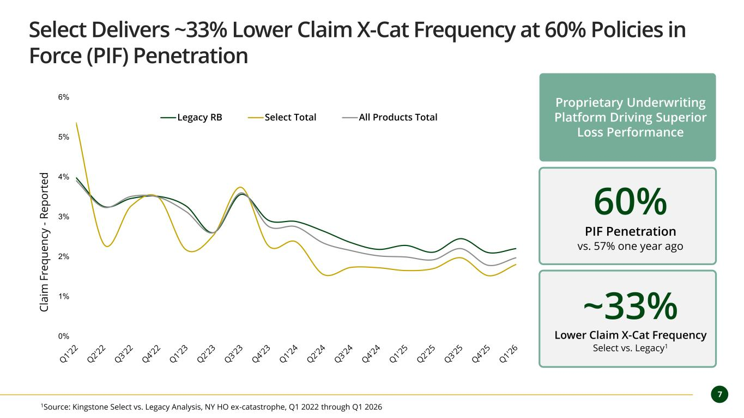
7 Select Delivers ~33% Lower Claim X-Cat Frequency at 60% Policies in Force (PIF) Penetration 0% 1% 2% 3% 4% 5% 6% C la im F re q u e n cy - R e p o rt e d Legacy RB Select Total All Products Total 60% PIF Penetration vs. 57% one year ago 1Source: Kingstone Select vs. Legacy Analysis, NY HO ex-catastrophe, Q1 2022 through Q1 2026 ~33% Lower Claim X-Cat Frequency Select vs. Legacy1 Proprietary Underwriting Platform Driving Superior Loss Performance

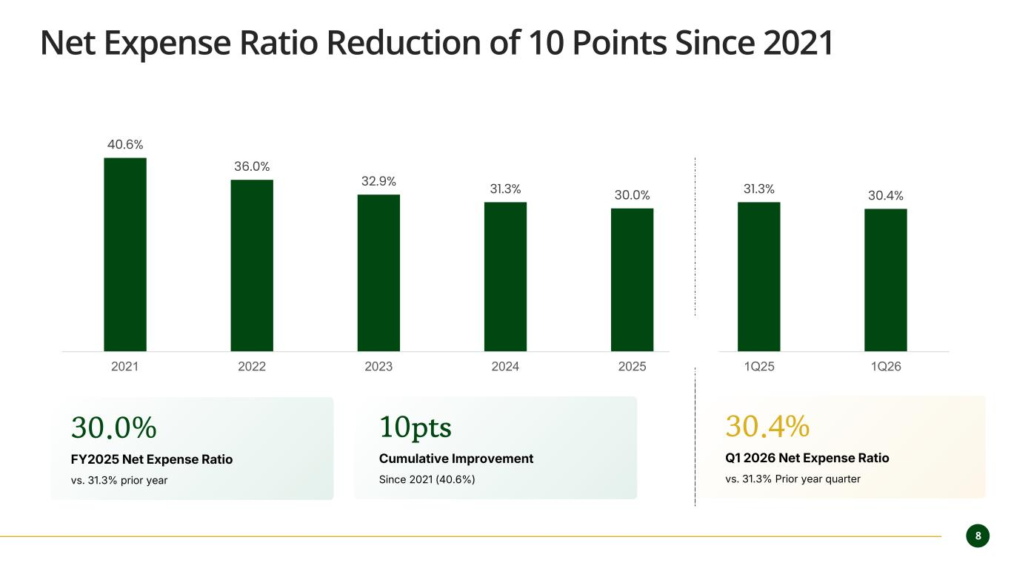
8 Net Expense Ratio Reduction of 10 Points Since 2021 40.6% 36.0% 32.9% 31.3% 30.0% 31.3% 30.4% 2021 2022 2023 2024 2025 1Q25 1Q26 30.0% FY2025 Net Expense Ratio vs. 31.3% prior year 30.4% Q1 2026 Net Expense Ratio vs. 31.3% Prior year quarter 10pts Cumulative Improvement Since 2021 (40.6%)

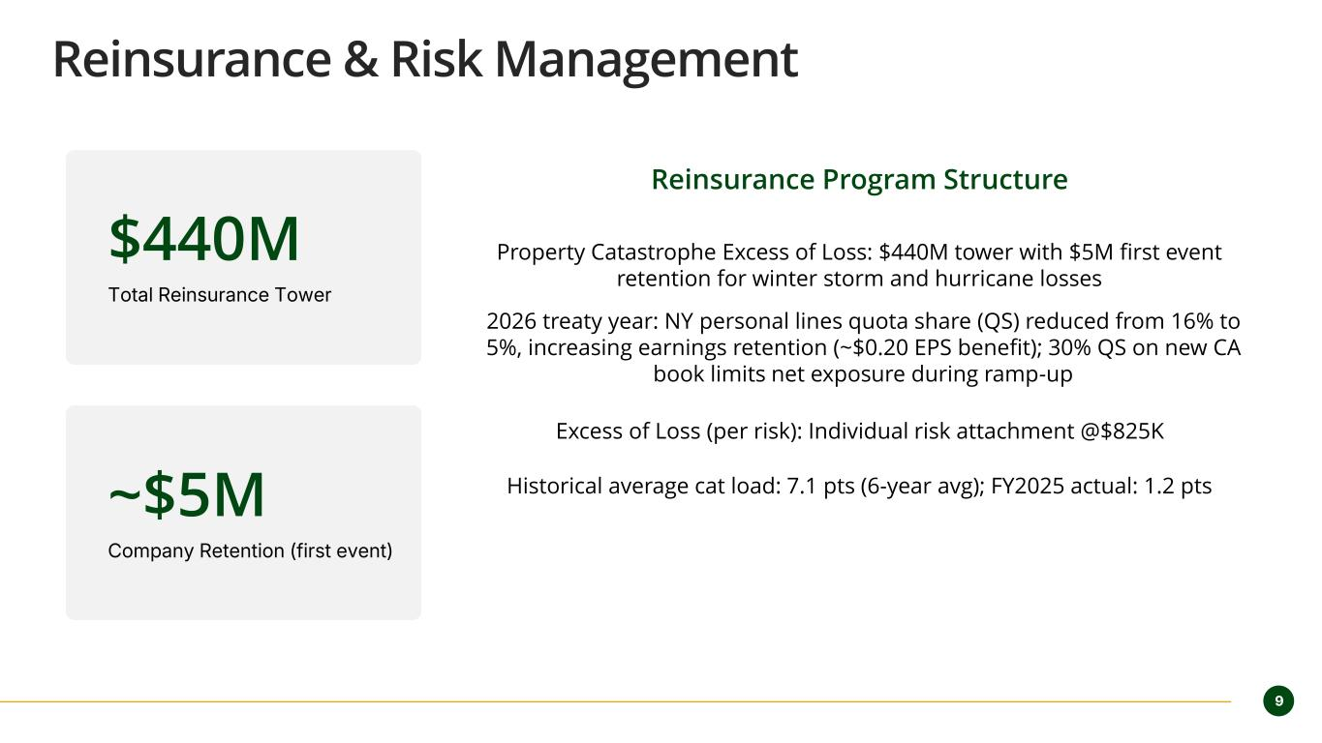
9 Reinsurance & Risk Management $440M Total Reinsurance Tower ~$5M Company Retention (first event) Reinsurance Program Structure Property Catastrophe Excess of Loss: $440M tower with $5M first event retention for winter storm and hurricane losses 2026 treaty year: NY personal lines quota share (QS) reduced from 16% to 5%, increasing earnings retention (~$0.20 EPS benefit); 30% QS on new CA book limits net exposure during ramp-up Excess of Loss (per risk): Individual risk attachment @$825K Historical average cat load: 7.1 pts (6-year avg); FY2025 actual: 1.2 pts

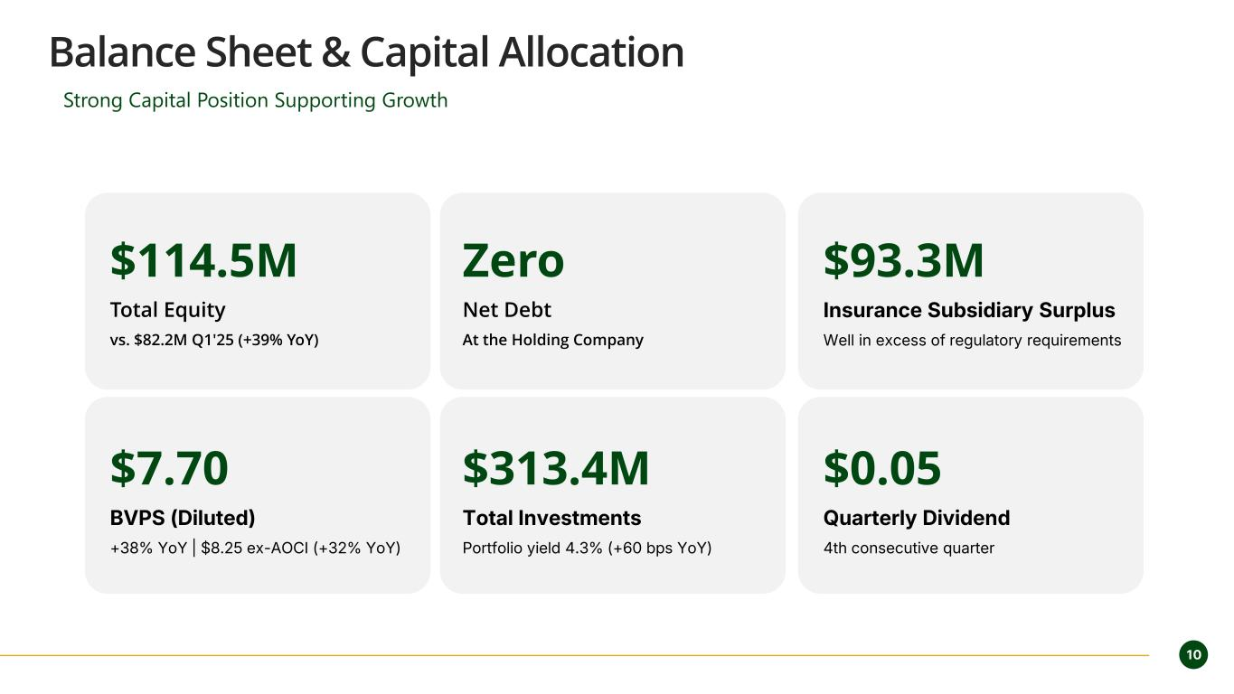
10 Balance Sheet & Capital Allocation Strong Capital Position Supporting Growth $114.5M Total Equity vs. $82.2M Q1'25 (+39% YoY) Zero Net Debt At the Holding Company $93.3M Insurance Subsidiary Surplus Well in excess of regulatory requirements $7.70 BVPS (Diluted) +38% YoY | $8.25 ex-AOCI (+32% YoY) $313.4M Total Investments Portfolio yield 4.3% (+60 bps YoY) $0.05 Quarterly Dividend 4th consecutive quarter

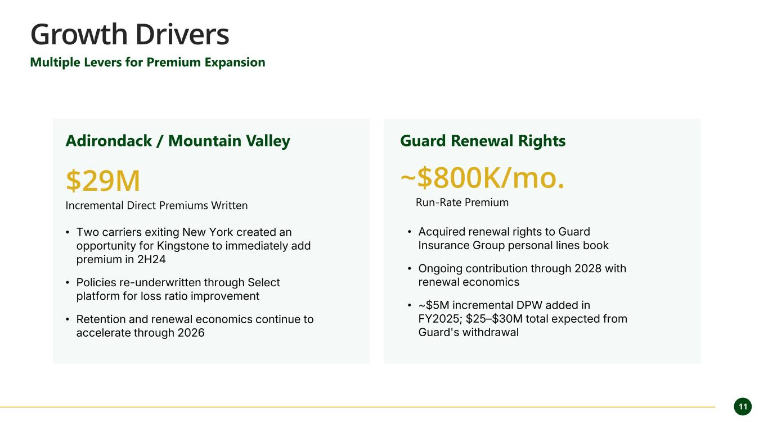
11 Growth Drivers Multiple Levers for Premium Expansion Adirondack / Mountain Valley $29M Incremental Direct Premiums Written • Two carriers exiting New York created an opportunity for Kingstone to immediately add premium in 2H24 • Policies re-underwritten through Select platform for loss ratio improvement • Retention and renewal economics continue to accelerate through 2026 Guard Renewal Rights ~$800K/mo. Run-Rate Premium • Acquired renewal rights to Guard Insurance Group personal lines book • Ongoing contribution through 2028 with renewal economics • ~$5M incremental DPW added in FY2025; $25–$30M total expected from Guard's withdrawal

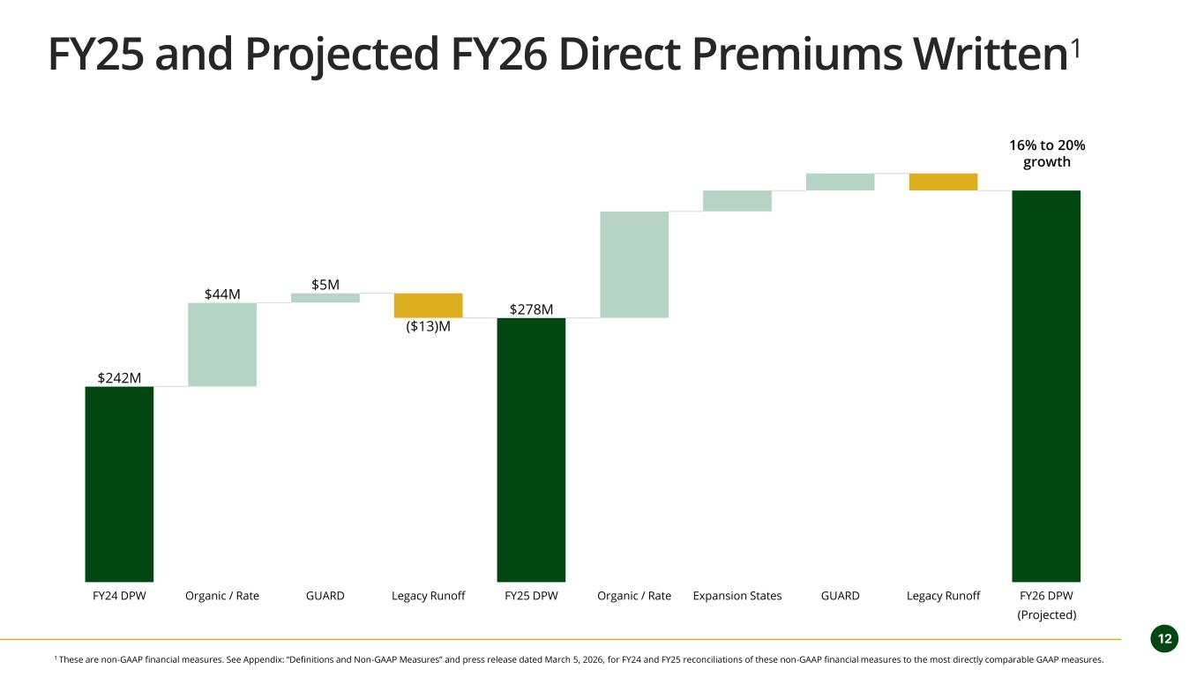
12 FY25 and Projected FY26 Direct Premiums Written1 $242M $44M $5M $278M ($13)M FY24 DPW Organic / Rate GUARD Legacy Runoff FY25 DPW Organic / Rate Expansion States GUARD Legacy Runoff FY26 DPW 16% to 20% growth (Projected) 1 These are non-GAAP financial measures. See Appendix: “Definitions and Non-GAAP Measures” and press release dated March 5, 2026, for FY24 and FY25 reconciliations of these non-GAAP financial measures to the most directly comparable GAAP measures.

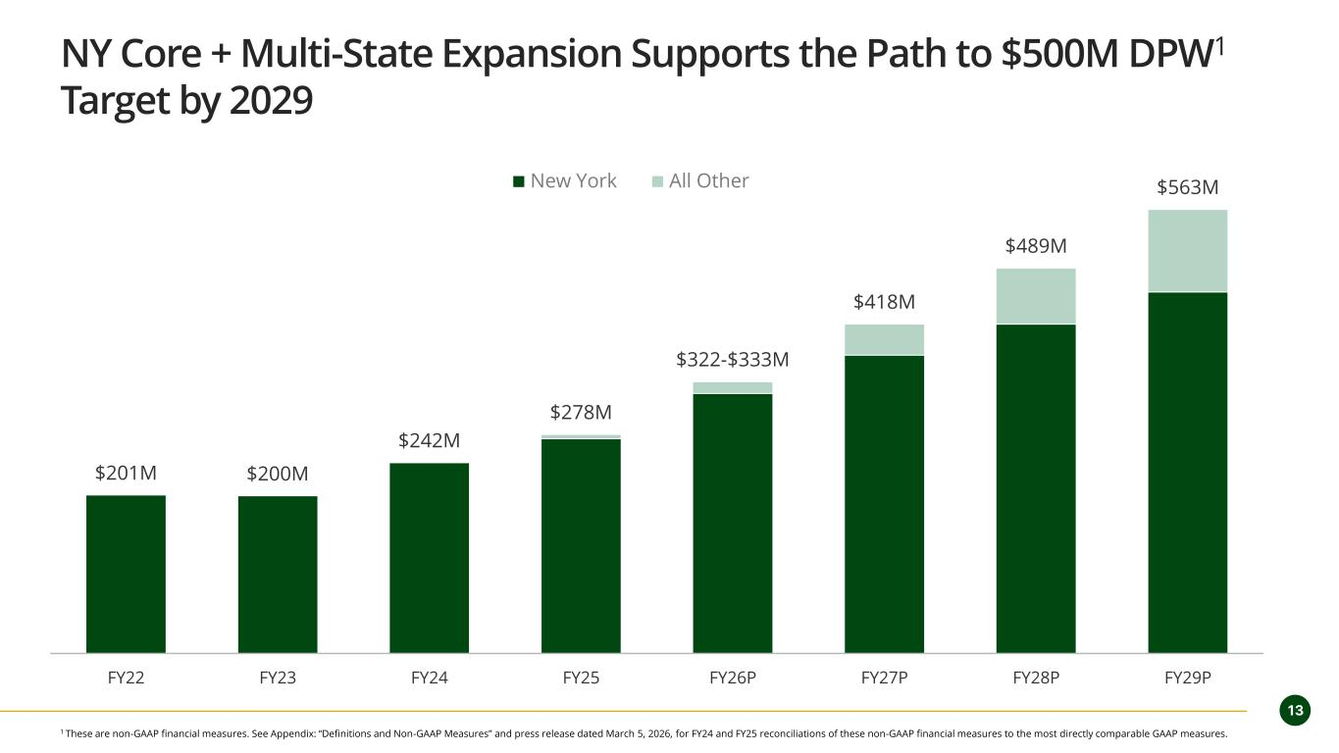
13 NY Core + Multi-State Expansion Supports the Path to $500M DPW1 Target by 2029 $201M $200M $242M $278M $322-$333M $418M $489M $563M $0M $100M $200M $300M $400M $500M $600M FY22 FY23 FY24 FY25 FY26P FY27P FY28P FY29P New York All Other 1 These are non-GAAP financial measures. See Appendix: “Definitions and Non-GAAP Measures” and press release dated March 5, 2026, for FY24 and FY25 reconciliations of these non-GAAP financial measures to the most directly comparable GAAP measures.

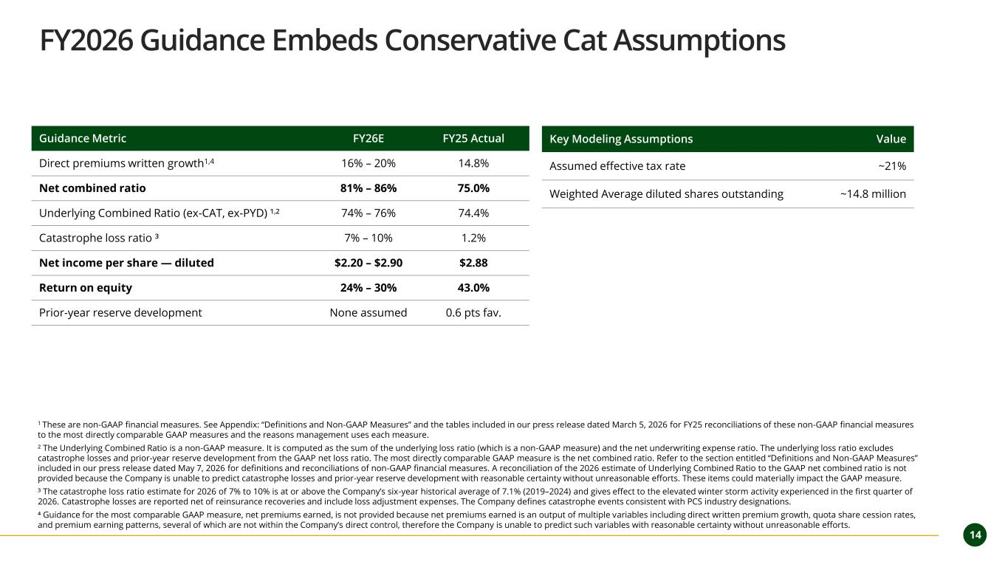
14 FY2026 Guidance Embeds Conservative Cat Assumptions 1 These are non-GAAP financial measures. See Appendix: “Definitions and Non-GAAP Measures” and the tables included in our press release dated March 5, 2026 for FY25 reconciliations of these non-GAAP financial measures to the most directly comparable GAAP measures and the reasons management uses each measure. ² The Underlying Combined Ratio is a non-GAAP measure. It is computed as the sum of the underlying loss ratio (which is a non-GAAP measure) and the net underwriting expense ratio. The underlying loss ratio excludes catastrophe losses and prior-year reserve development from the GAAP net loss ratio. The most directly comparable GAAP measure is the net combined ratio. Refer to the section entitled “Definitions and Non-GAAP Measures” included in our press release dated May 7, 2026 for definitions and reconciliations of non-GAAP financial measures. A reconciliation of the 2026 estimate of Underlying Combined Ratio to the GAAP net combined ratio is not provided because the Company is unable to predict catastrophe losses and prior-year reserve development with reasonable certainty without unreasonable efforts. These items could materially impact the GAAP measure. ³ The catastrophe loss ratio estimate for 2026 of 7% to 10% is at or above the Company’s six-year historical average of 7.1% (2019–2024) and gives effect to the elevated winter storm activity experienced in the first quarter of 2026. Catastrophe losses are reported net of reinsurance recoveries and include loss adjustment expenses. The Company defines catastrophe events consistent with PCS industry designations. ⁴ Guidance for the most comparable GAAP measure, net premiums earned, is not provided because net premiums earned is an output of multiple variables including direct written premium growth, quota share cession rates, and premium earning patterns, several of which are not within the Company’s direct control, therefore the Company is unable to predict such variables with reasonable certainty without unreasonable efforts. Guidance Metric FY26E FY25 Actual Direct premiums written growth1,4 16% – 20% 14.8% Net combined ratio 81% – 86% 75.0% Underlying Combined Ratio (ex-CAT, ex-PYD) ¹,² 74% – 76% 74.4% Catastrophe loss ratio ³ 7% – 10% 1.2% Net income per share — diluted $2.20 – $2.90 $2.88 Return on equity 24% – 30% 43.0% Prior-year reserve development None assumed 0.6 pts fav. Key Modeling Assumptions Value Assumed effective tax rate ~21% Weighted Average diluted shares outstanding ~14.8 million

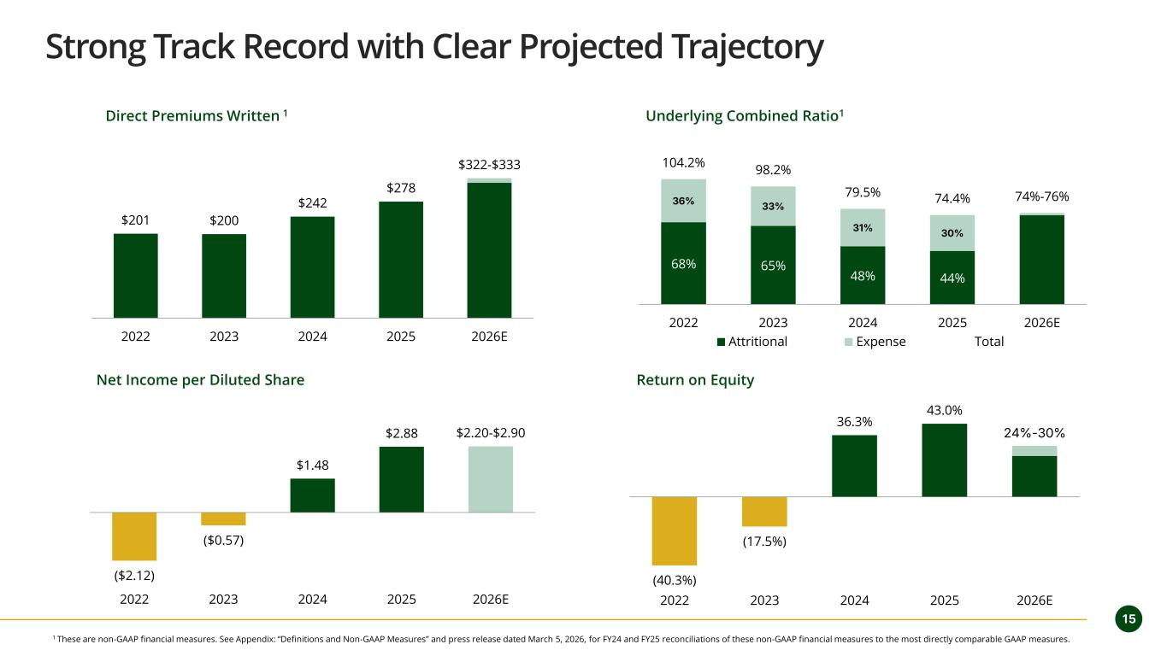
15 Strong Track Record with Clear Projected Trajectory $201 $200 $242 $278 $322-$333 2022 2023 2024 2025 2026E 68% 65% 48% 44% 36% 33% 31% 30% 104.2% 98.2% 79.5% 74.4% 74%-76% 0 2022 2023 2024 2025 2026E Attritional Expense Total ($2.12) ($0.57) $1.48 $2.88 $2.20-$2.90 2022 2023 2024 2025 2026E (40.3%) (17.5%) 36.3% 43.0% 24%-30% 2022 2023 2024 2025 2026E Direct Premiums Written 1 Underlying Combined Ratio1 Net Income per Diluted Share Return on Equity 1 These are non-GAAP financial measures. See Appendix: “Definitions and Non-GAAP Measures” and press release dated March 5, 2026, for FY24 and FY25 reconciliations of these non-GAAP financial measures to the most directly comparable GAAP measures.


16 Executive Management Team Meryl S. Golden President & CEO 30+ years Joined 2019 as COO; appointed CEO Oct 2023 Progressive · Liberty Mutual · Earnix · Bridgewater Randy L. Patten Vice President & CFO 25+ years Joined Aug 2025; led finance through NEXT Insurance's $2.6B acquisition NEXT Insurance · United Fire Group · Transamerica Sarah (Minlei) Chen SVP, Chief Actuary & Head of Product Mgmt 10+ years Joined Nov 2020; product development and actuarial pricing Homesite · Plymouth Rock · Travelers David Fernandez SVP & Chief Claims Officer 25+ years Joined Nov 2023; led 1,000+ claims professionals at prior carriers Progressive · Liberty Mutual · Point32Health 90+ Years Combined Insurance Leadership

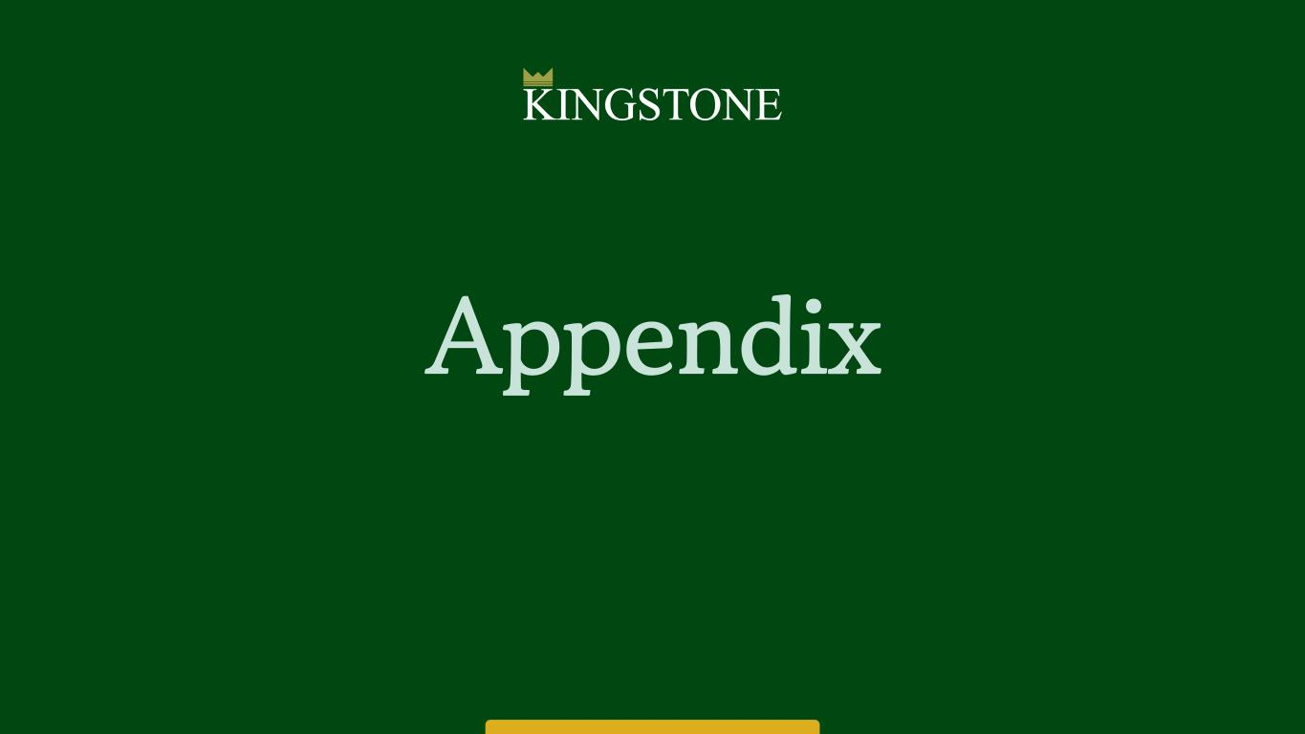
17 Appendix

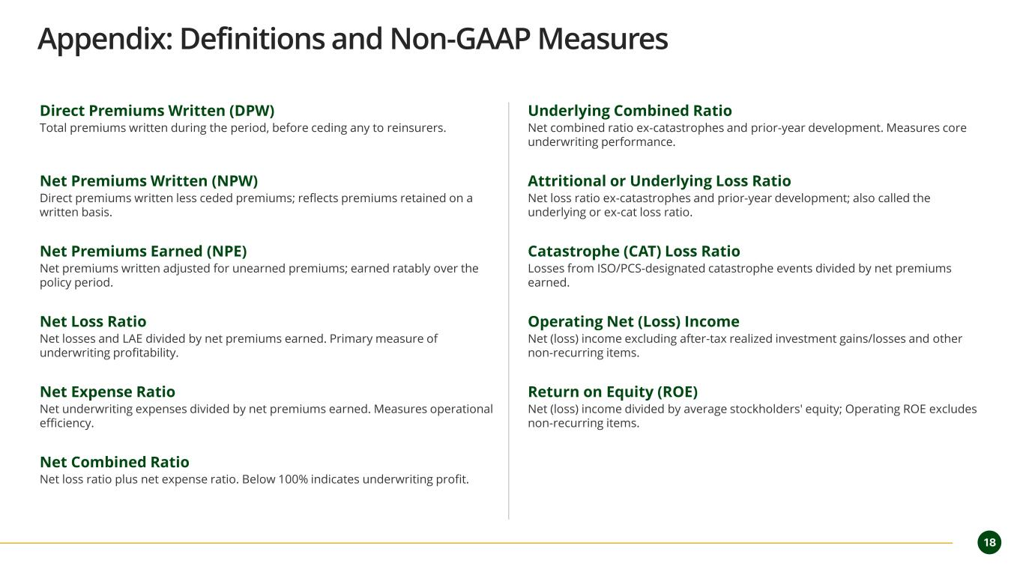
18 Appendix: Definitions and Non-GAAP Measures Direct Premiums Written (DPW) Total premiums written during the period, before ceding any to reinsurers. Net Premiums Written (NPW) Direct premiums written less ceded premiums; reflects premiums retained on a written basis. Net Premiums Earned (NPE) Net premiums written adjusted for unearned premiums; earned ratably over the policy period. Net Loss Ratio Net losses and LAE divided by net premiums earned. Primary measure of underwriting profitability. Net Expense Ratio Net underwriting expenses divided by net premiums earned. Measures operational efficiency. Net Combined Ratio Net loss ratio plus net expense ratio. Below 100% indicates underwriting profit. Underlying Combined Ratio Net combined ratio ex-catastrophes and prior-year development. Measures core underwriting performance. Attritional or Underlying Loss Ratio Net loss ratio ex-catastrophes and prior-year development; also called the underlying or ex-cat loss ratio. Catastrophe (CAT) Loss Ratio Losses from ISO/PCS-designated catastrophe events divided by net premiums earned. Operating Net (Loss) Income Net (loss) income excluding after-tax realized investment gains/losses and other non-recurring items. Return on Equity (ROE) Net (loss) income divided by average stockholders' equity; Operating ROE excludes non-recurring items.

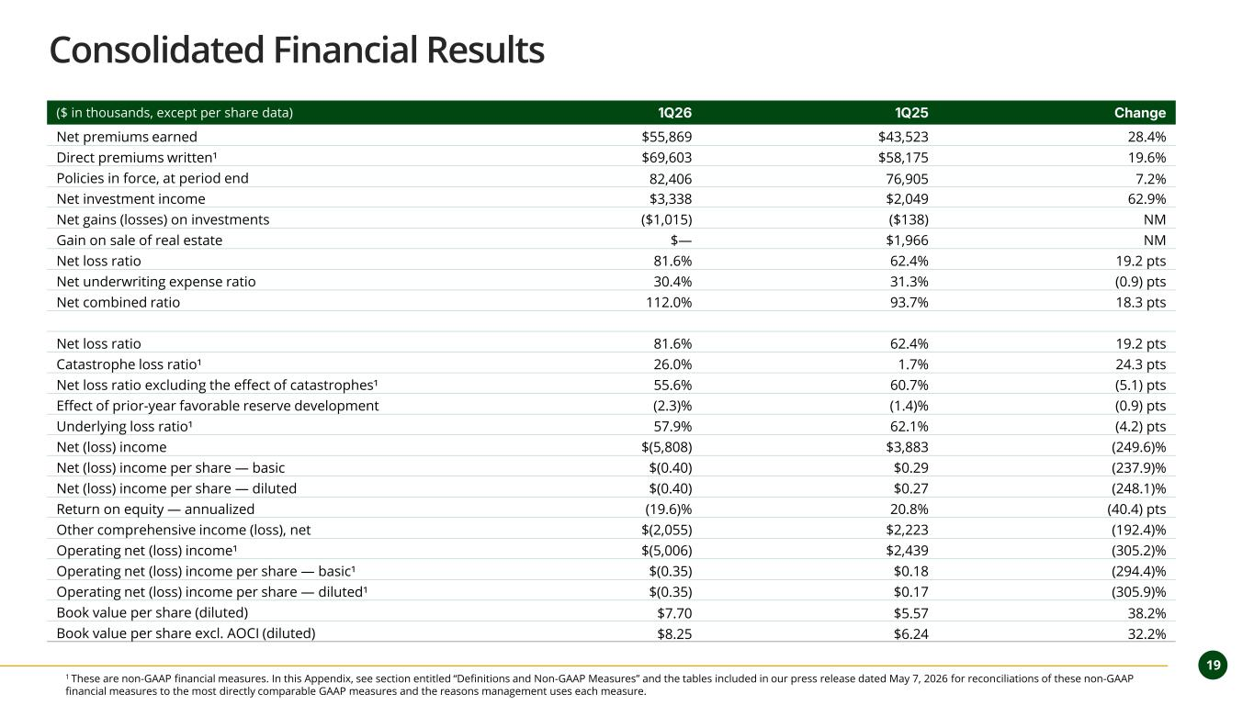
19 Consolidated Financial Results ($ in thousands, except per share data) 1Q26 1Q25 Change Net premiums earned $55,869 $43,523 28.4% Direct premiums written¹ $69,603 $58,175 19.6% Policies in force, at period end 82,406 76,905 7.2% Net investment income $3,338 $2,049 62.9% Net gains (losses) on investments ($1,015) ($138) NM Gain on sale of real estate $— $1,966 NM Net loss ratio 81.6% 62.4% 19.2 pts Net underwriting expense ratio 30.4% 31.3% (0.9) pts Net combined ratio 112.0% 93.7% 18.3 pts Net loss ratio 81.6% 62.4% 19.2 pts Catastrophe loss ratio¹ 26.0% 1.7% 24.3 pts Net loss ratio excluding the effect of catastrophes¹ 55.6% 60.7% (5.1) pts Effect of prior-year favorable reserve development (2.3)% (1.4)% (0.9) pts Underlying loss ratio¹ 57.9% 62.1% (4.2) pts Net (loss) income $(5,808) $3,883 (249.6)% Net (loss) income per share — basic $(0.40) $0.29 (237.9)% Net (loss) income per share — diluted $(0.40) $0.27 (248.1)% Return on equity — annualized (19.6)% 20.8% (40.4) pts Other comprehensive income (loss), net $(2,055) $2,223 (192.4)% Operating net (loss) income¹ $(5,006) $2,439 (305.2)% Operating net (loss) income per share — basic¹ $(0.35) $0.18 (294.4)% Operating net (loss) income per share — diluted¹ $(0.35) $0.17 (305.9)% Book value per share (diluted) $7.70 $5.57 38.2% Book value per share excl. AOCI (diluted) $8.25 $6.24 32.2% 1 These are non-GAAP financial measures. In this Appendix, see section entitled “Definitions and Non-GAAP Measures” and the tables included in our press release dated May 7, 2026 for reconciliations of these non-GAAP financial measures to the most directly comparable GAAP measures and the reasons management uses each measure.

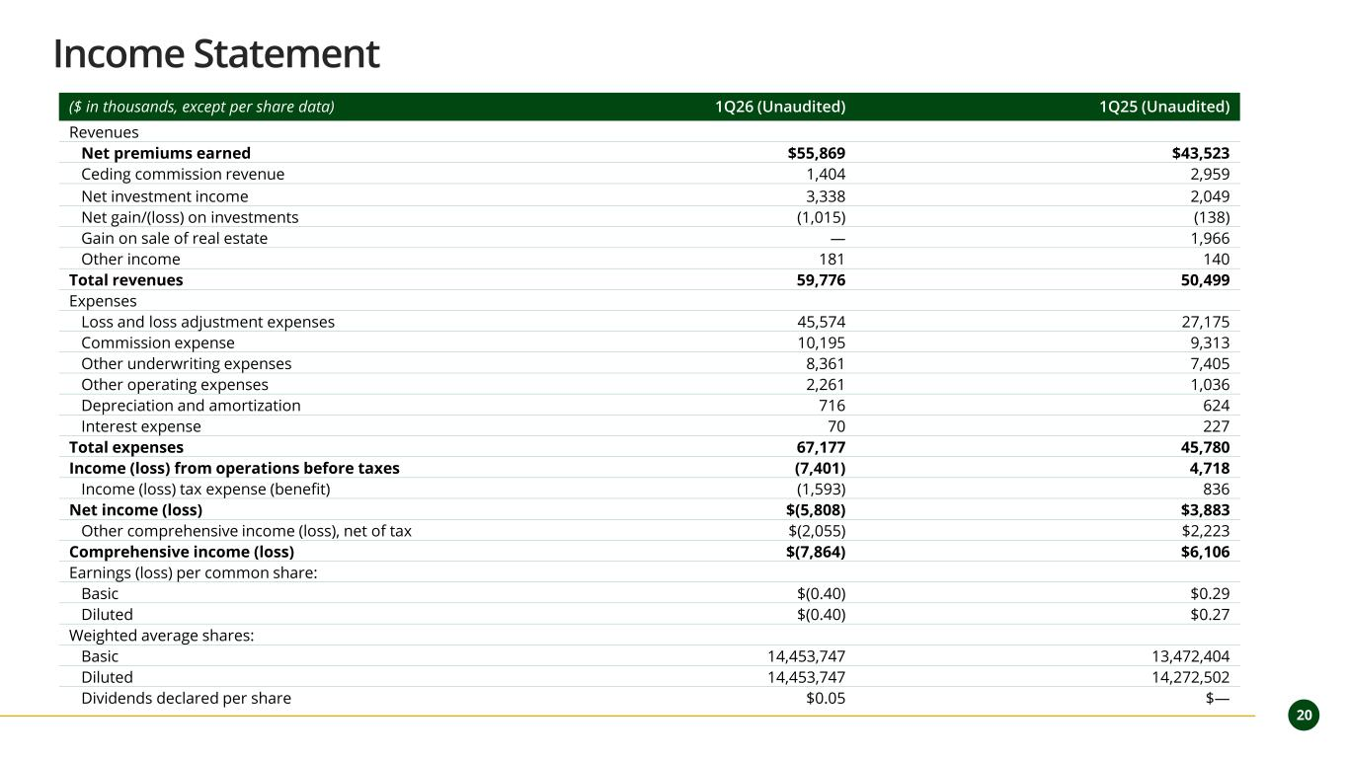
2 0 20 Income Statement ($ in thousands, except per share data) 1Q26 (Unaudited) 1Q25 (Unaudited) Revenues Net premiums earned $55,869 $43,523 Ceding commission revenue 1,404 2,959 Net investment income 3,338 2,049 Net gain/(loss) on investments (1,015) (138) Gain on sale of real estate — 1,966 Other income 181 140 Total revenues 59,776 50,499 Expenses Loss and loss adjustment expenses 45,574 27,175 Commission expense 10,195 9,313 Other underwriting expenses 8,361 7,405 Other operating expenses 2,261 1,036 Depreciation and amortization 716 624 Interest expense 70 227 Total expenses 67,177 45,780 Income (loss) from operations before taxes (7,401) 4,718 Income (loss) tax expense (benefit) (1,593) 836 Net income (loss) $(5,808) $3,883 Other comprehensive income (loss), net of tax $(2,055) $2,223 Comprehensive income (loss) $(7,864) $6,106 Earnings (loss) per common share: Basic $(0.40) $0.29 Diluted $(0.40) $0.27 Weighted average shares: Basic 14,453,747 13,472,404 Diluted 14,453,747 14,272,502 Dividends declared per share $0.05 $—

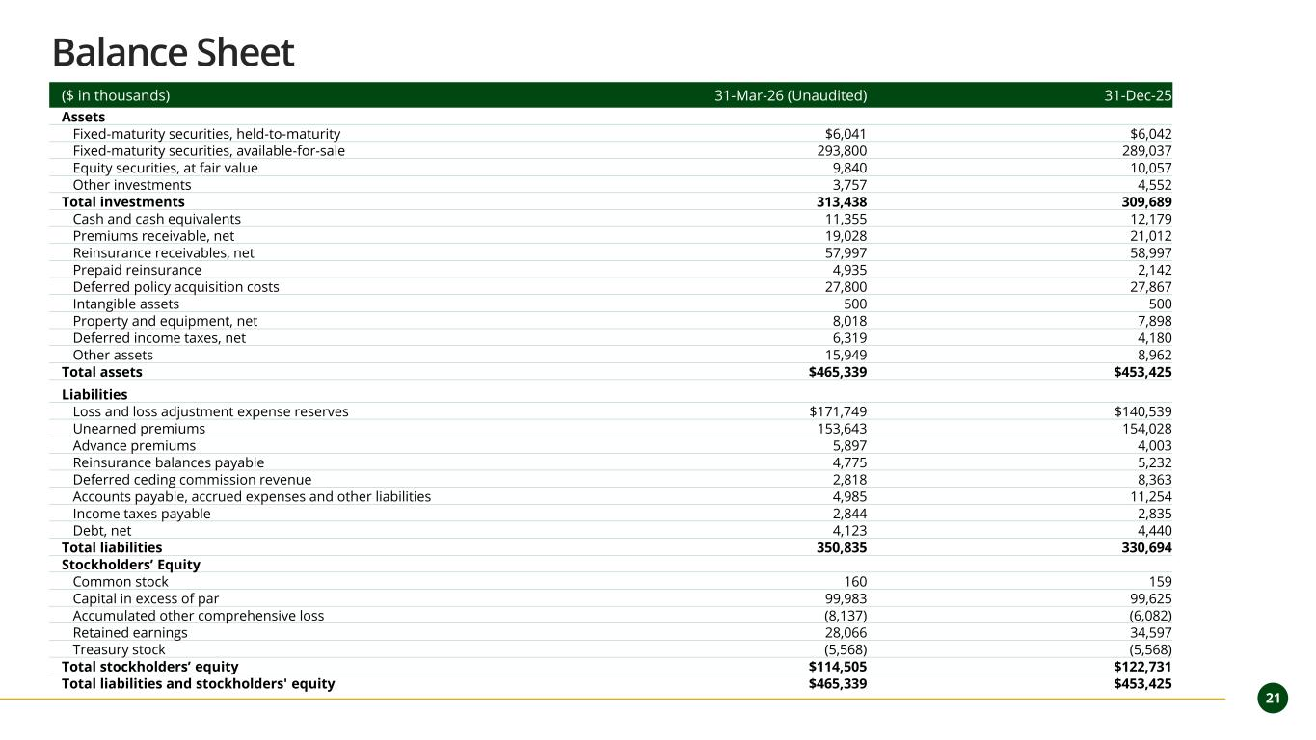
21 ($ in thousands) 31-Mar-26 (Unaudited) 31-Dec-25 Assets Fixed-maturity securities, held-to-maturity $6,041 $6,042 Fixed-maturity securities, available-for-sale 293,800 289,037 Equity securities, at fair value 9,840 10,057 Other investments 3,757 4,552 Total investments 313,438 309,689 Cash and cash equivalents 11,355 12,179 Premiums receivable, net 19,028 21,012 Reinsurance receivables, net 57,997 58,997 Prepaid reinsurance 4,935 2,142 Deferred policy acquisition costs 27,800 27,867 Intangible assets 500 500 Property and equipment, net 8,018 7,898 Deferred income taxes, net 6,319 4,180 Other assets 15,949 8,962 Total assets $465,339 $453,425 Liabilities Loss and loss adjustment expense reserves $171,749 $140,539 Unearned premiums 153,643 154,028 Advance premiums 5,897 4,003 Reinsurance balances payable 4,775 5,232 Deferred ceding commission revenue 2,818 8,363 Accounts payable, accrued expenses and other liabilities 4,985 11,254 Income taxes payable 2,844 2,835 Debt, net 4,123 4,440 Total liabilities 350,835 330,694 Stockholders’ Equity Common stock 160 159 Capital in excess of par 99,983 99,625 Accumulated other comprehensive loss (8,137) (6,082) Retained earnings 28,066 34,597 Treasury stock (5,568) (5,568) Total stockholders’ equity $114,505 $122,731 Total liabilities and stockholders' equity $465,339 $453,425 Balance Sheet



